**Deploy 3 Tier Architecture, Configure Security Group and Autoscaling – Assignment**

1. **Introduction**
   1. **Problem Description:**

One specific problem within the cloud environment is the lack of a structured architecture to efficiently handle the deployment and management of applications. Without a well-defined architecture, organizations face challenges related to scalability, security, and maintainability. Specifically, the absence of a structured approach can lead to monolithic applications, making it difficult to scale components independently, secure sensitive data, and maintain agility in development and deployment processes. Additionally, without a clear separation of concerns, troubleshooting and debugging become more complex, impacting operational efficiency and hindering innovation.

* 1. **Consequences:**

Scalability becomes a major issue as applications grow and user demands increase.

Security vulnerabilities arise due to the lack of isolation between different components of the application. Without clear boundaries between layers, sensitive data stored within the application may be more susceptible to unauthorized access or data breaches.

The absence of a structured architecture inhibits agility and innovation. Monolithic applications are harder to update and maintain, slowing down the development and deployment cycles.

* 1. **Solution using 3-tier structure with AWS:**

By adopting a three-tier architecture with AWS services, organizations can address scalability, security, and maintainability challenges effectively. The structured separation of concerns enables independent scaling of components, improves security by isolating sensitive data, and enhances agility through automation and deployment flexibility. This approach empowers organizations to leverage the full potential of cloud technology while ensuring optimal performance, security, and cost efficiency.

Here are some specific aspects of this challenge:

|  |  |  |
| --- | --- | --- |
| **Aspects** | **Challenges** | **Solution** |
| **Cost Visibility** | Many organizations struggle to gain visibility into their cloud spending across multiple services, regions, and accounts. This lack of visibility makes it difficult to understand where costs are coming from and how they can be optimized. | Use AWS Cost Explorer to gain visibility into your AWS spending by service, region, instance type, and more. |
| Enable detailed billing to get granular insights into resource usage and costs. |
| Set up AWS Budgets to create custom cost and usage budgets with alerts when thresholds are exceeded. |
| **Resource Utilization** | Cloud resources, such as virtual machines and storage, are often provisioned with excess capacity to accommodate potential spikes in demand. However, this can lead to underutilization and unnecessary costs if resources are not rightsized or scaled dynamically based on actual usage. | Utilize AWS Trusted Advisor to identify underutilized resources and recommend rightsizing opportunities. |
| Implement AWS Auto Scaling to dynamically scale resources based on demand, optimizing resource utilization and cost. |
| Consider using AWS Savings Plans or Reserved Instances to commit to usage in exchange for significant discounts |
| **Complex Pricing Models** | Cloud resources, such as virtual machines and storage, are often provisioned with excess capacity to accommodate potential spikes in demand. However, this can lead to underutilization and unnecessary costs if resources are not rightsized or scaled dynamically based on actual usage. | Leverage AWS Pricing Calculator to estimate costs for various AWS services and configurations before deployment. |
| Explore AWS Cost Anomaly Detection to identify unexpected cost changes and investigate root causes. |
| Utilize Cost Allocation Tags to categorize resources for more granular cost analysis and tracking. |
| **Lack of Governance** | In multi-cloud or hybrid cloud environments, organizations may lack centralized governance and controls over resource provisioning and spending. This can result in instances of shadow IT, where departments or teams independently procure cloud resources without considering cost implications. | Implement AWS Organizations to centrally manage and govern multiple AWS accounts within your organization. |
| Use AWS Control Tower to set up and govern a secure, multi-account AWS environment based on AWS best practices. |
| Utilize AWS Service Catalog to create and manage approved catalogs of resources for standardized deployment. |
| **Optimization Strategies** | Implementing effective cost optimization strategies requires expertise in areas such as rightsizing, instance reservations, spot instances, storage lifecycle management, and container orchestration. Organizations may struggle to develop and implement these strategies without dedicated resources or tools. | Leverage AWS Compute Optimizer to analyze your EC2 instances and provide recommendations for right-sizing and instance type optimization. |
| Use AWS Cost Explorer's Cost Anomaly Detection and recommendations to identify areas for optimization. |
| Implement AWS Spot Instances or Spot Fleets for cost-effective, short-lived workloads with flexible pricing options. |
| **Security and Compliance** | Cost optimization efforts must also consider security and compliance requirements to ensure that cost-saving measures do not compromise data integrity, confidentiality, or regulatory compliance. | Implement AWS Identity and Access Management (IAM) to control access to AWS services and resources based on security policies. |
| Utilize AWS Config to assess, audit, and evaluate the configurations of your AWS resources for compliance with industry standards and best practices. |
| Leverage AWS CloudTrail for visibility into API activity and changes made to your AWS resources, aiding in security analysis, resource change tracking, and compliance auditing. |

1. **Architecture Overview**
   1. **The 3-tier architecture**

To address the above said challenges, organizations can implement a three-tier architecture using AWS services:

1. **Presentation Tier (Frontend)**:Deploy frontend components
2. **Application Tier (Backend)**:Deploy application logic and business processes
3. **Data Tier (Database)**:Deploy data storage and management services
   1. **Components involved (frontend, application tier, data tier)**

A three-tier architecture utilises the following components. For ease of use and isolation we will launch the entire 3 tier architecture within a separate Virtual Private Cloud.

1. **Presentation Tier (Frontend):**
   1. Web servers using Ec2 and S3
   2. Utilize AWS Identity and Access Management (IAM) to manage user access and permissions, ensuring secure access to frontend resources.
2. **Application Tier (Backend):**
   1. Deploy application logic and business processes using EC2 for virtual server hosting.
   2. Utilize AWS Application Load Balancer (ALB) to distribute traffic across multiple backend instances, improving availability and scalability.
3. **Data Tier (Database):**
   1. Deploy data storage and management services using Amazon RDS for relational databases-MySQL
4. **Networking**
   1. **Overview of the network setup using VPC (Virtual Private Cloud)**

When setting up a network in AWS, the first step is to create a VPC. We define the IP address range (CIDR block) for the VPC, which determines the range of IP addresses available for instances launched within the VPC. Here we have used the CIDR block as 172.20.0.0/20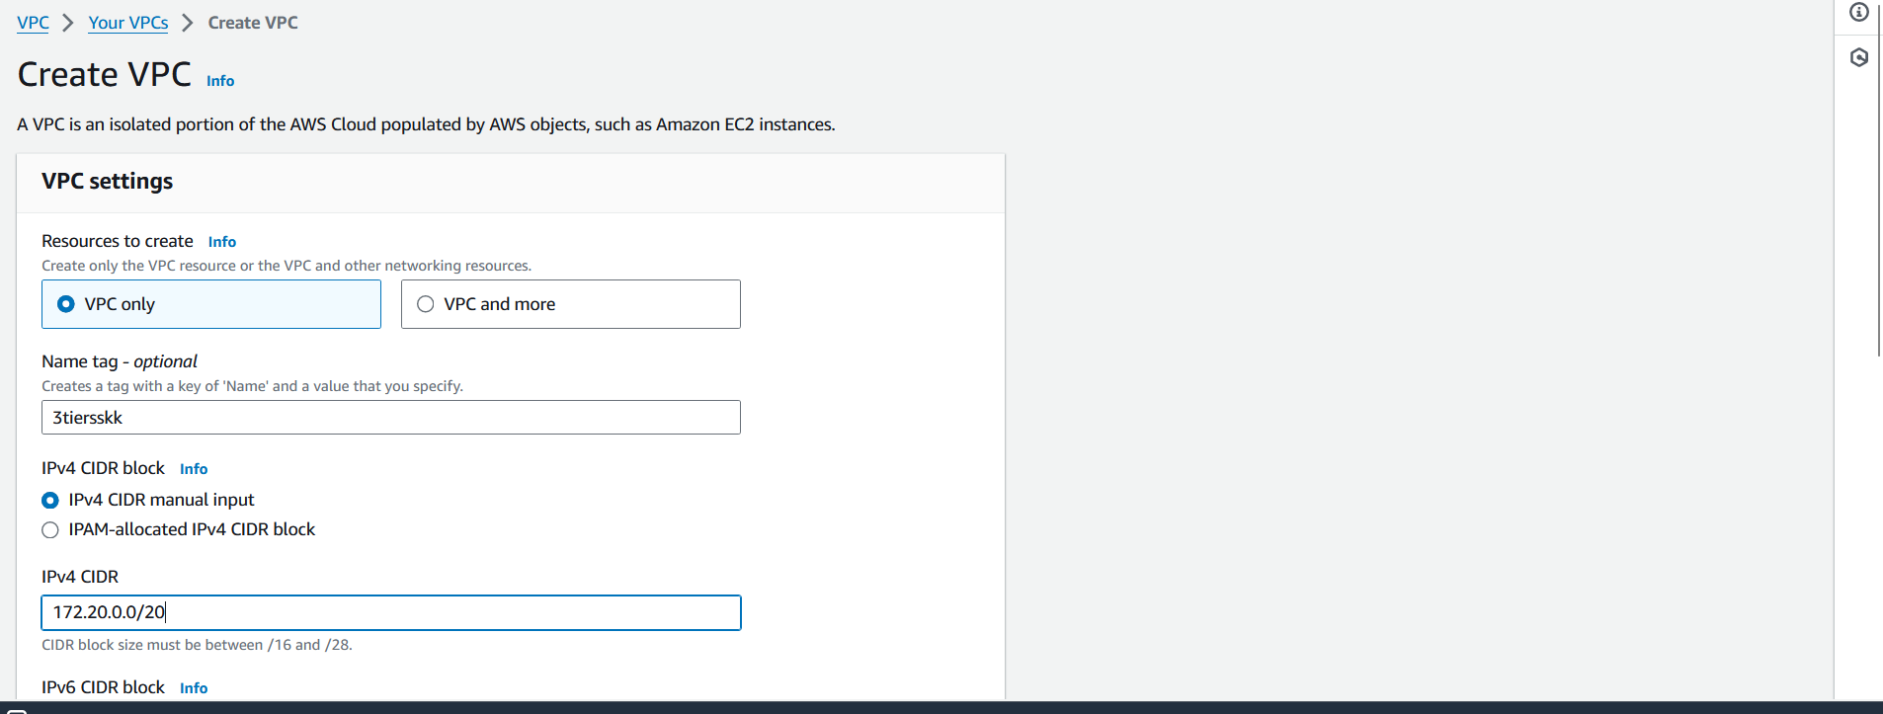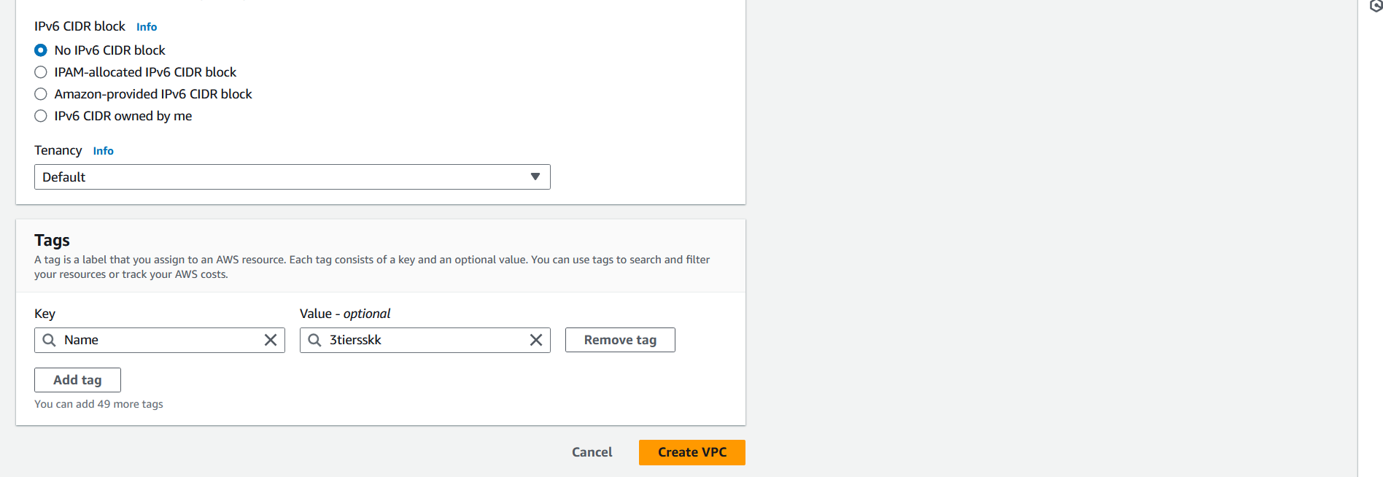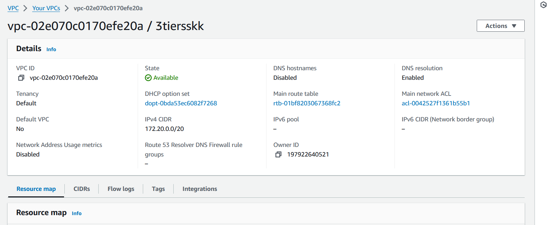

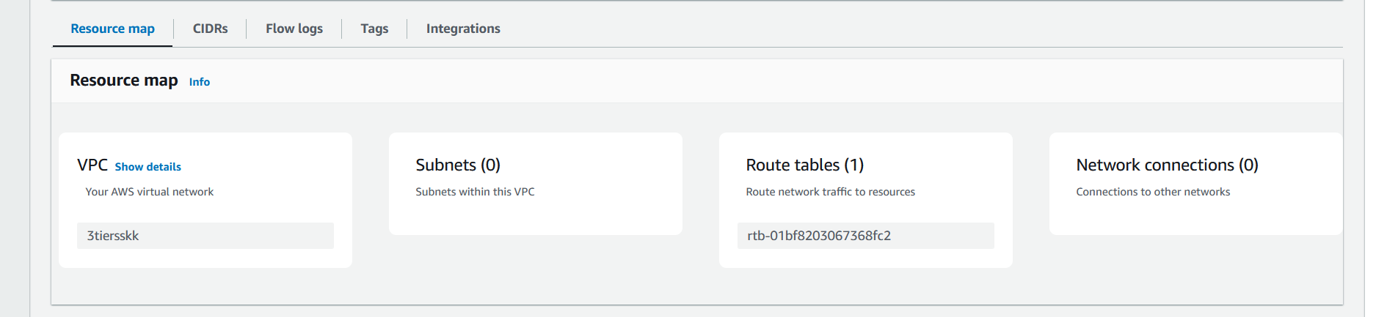

* 1. **Configuration of public and private subnets**
     1. **Create Public Subnet**

Navigate to the VPC dashboard in your cloud provider's console.

• Create a subnet with a CIDR block that falls within your VPC's CIDR range.

• Tag the subnet appropriately to identify it as a public subnet

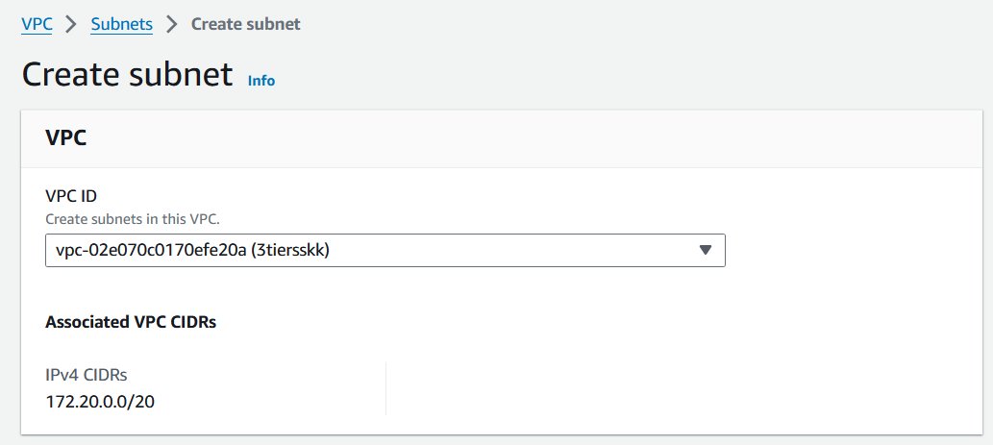

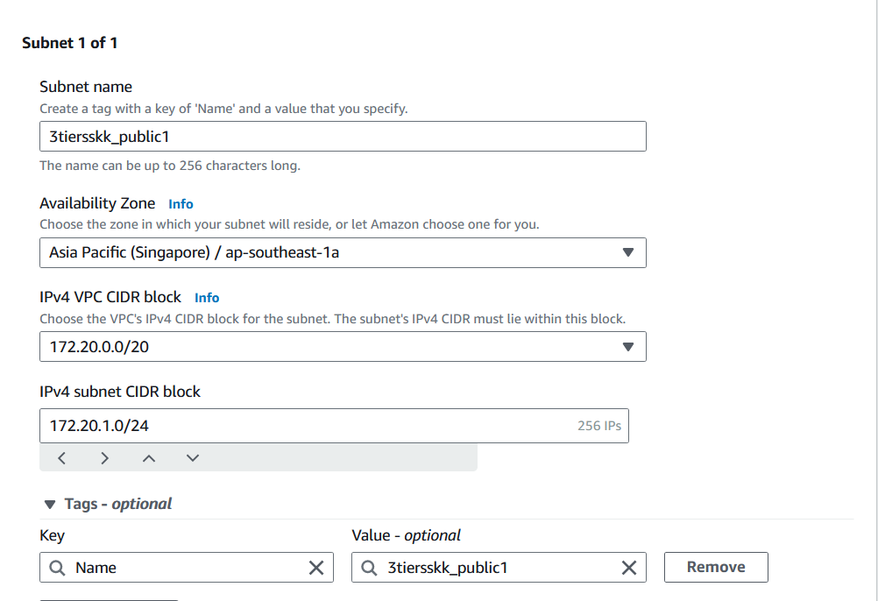

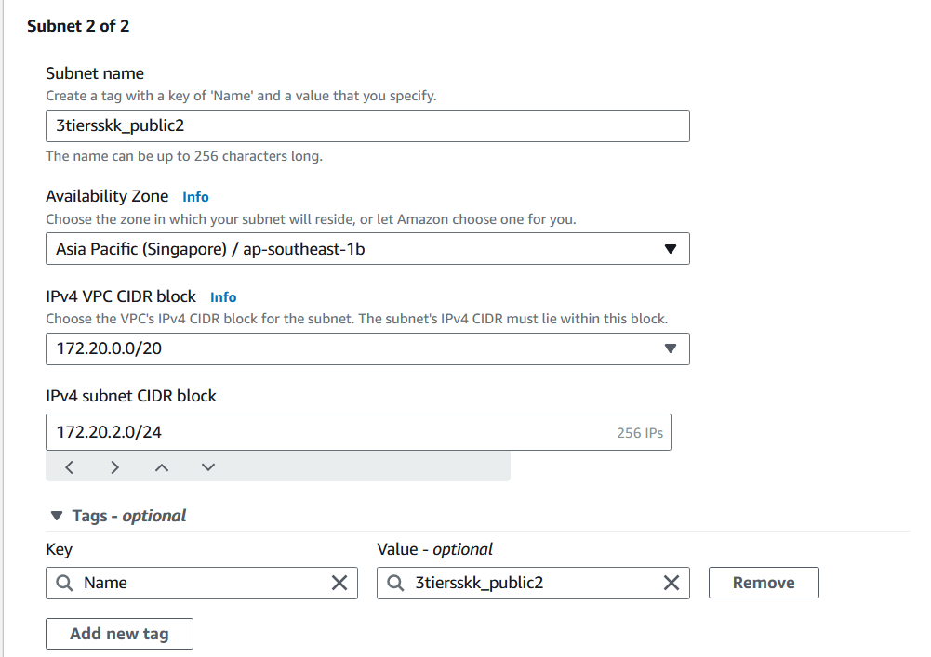

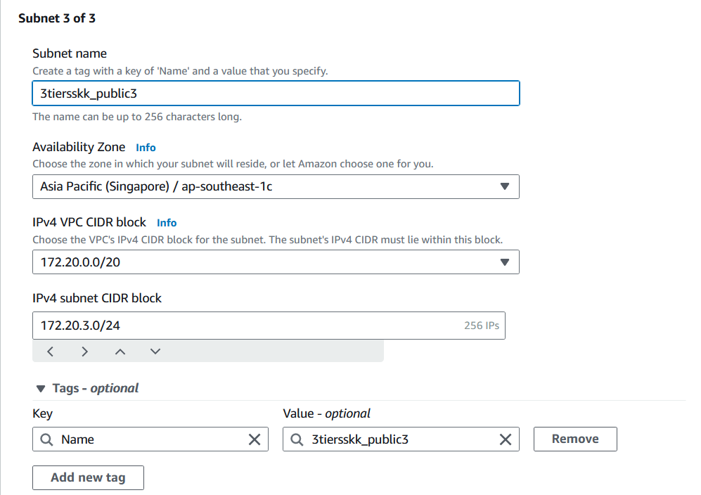

* + 1. **Create Private Subnet:**
* Similarly, create another subnet for private resources with a different CIDR block.
* Tag this subnet to identify it as a private subnet

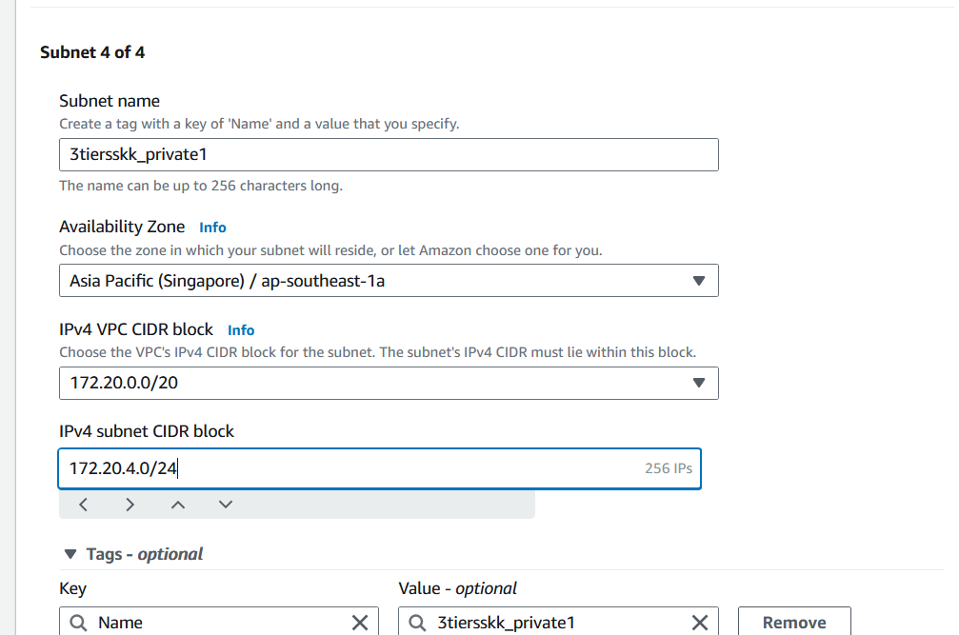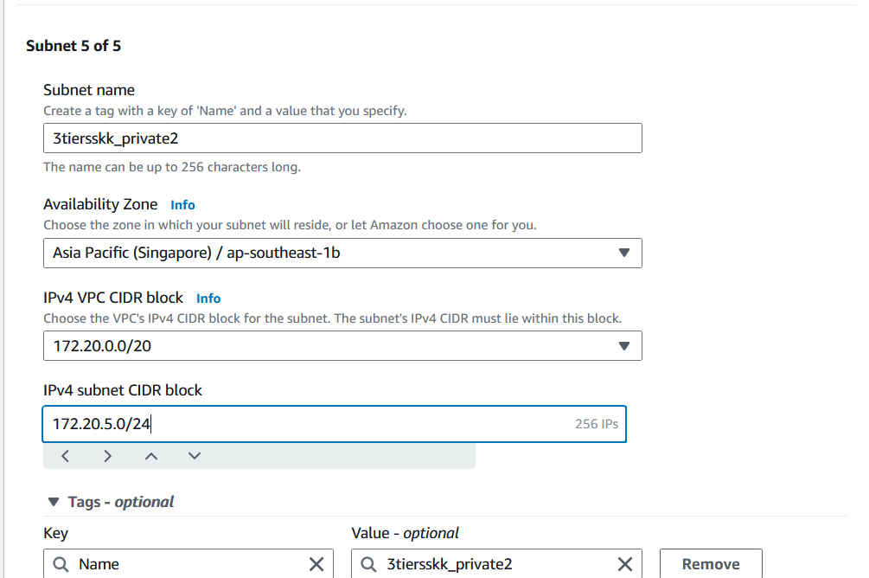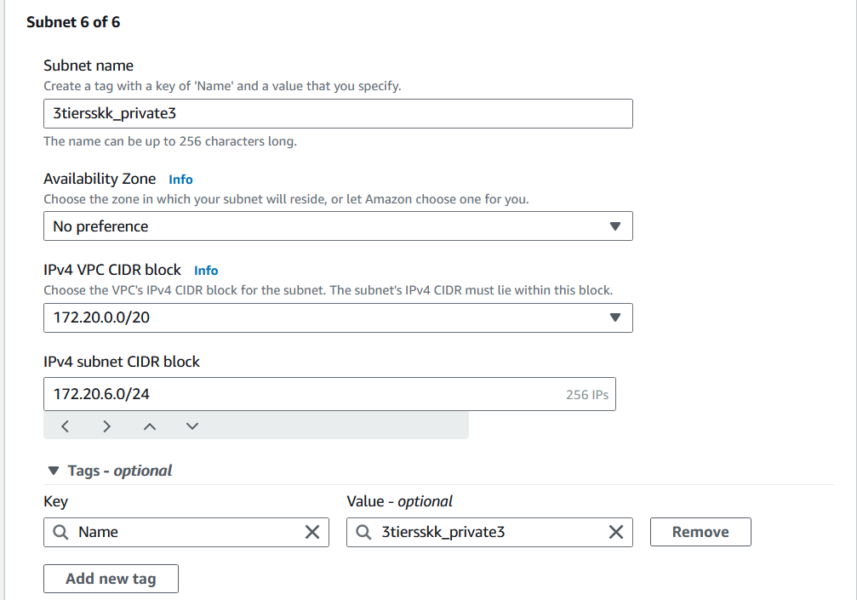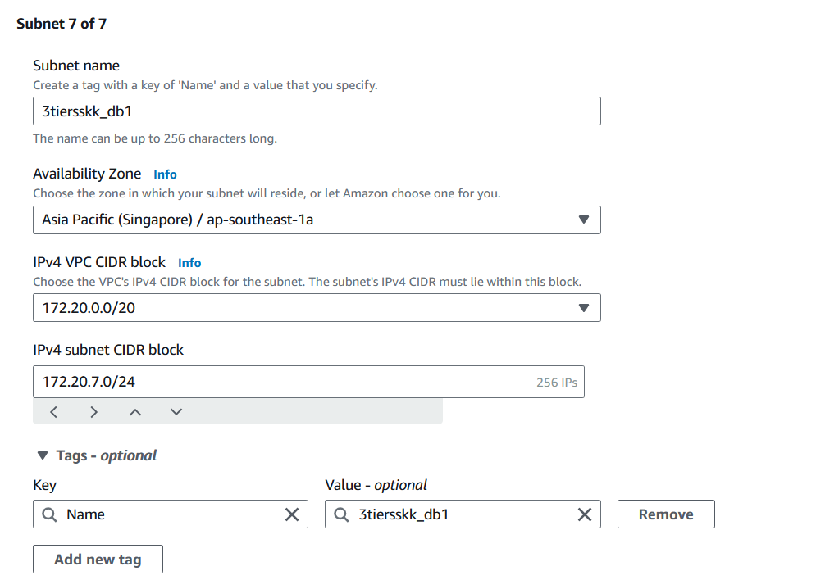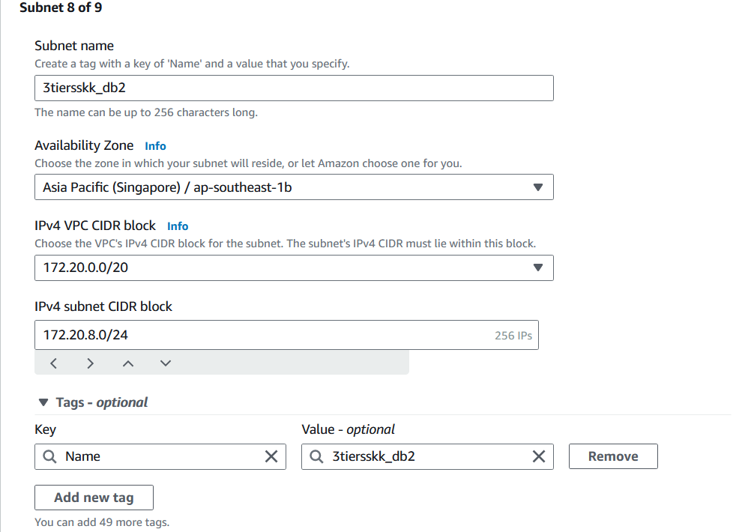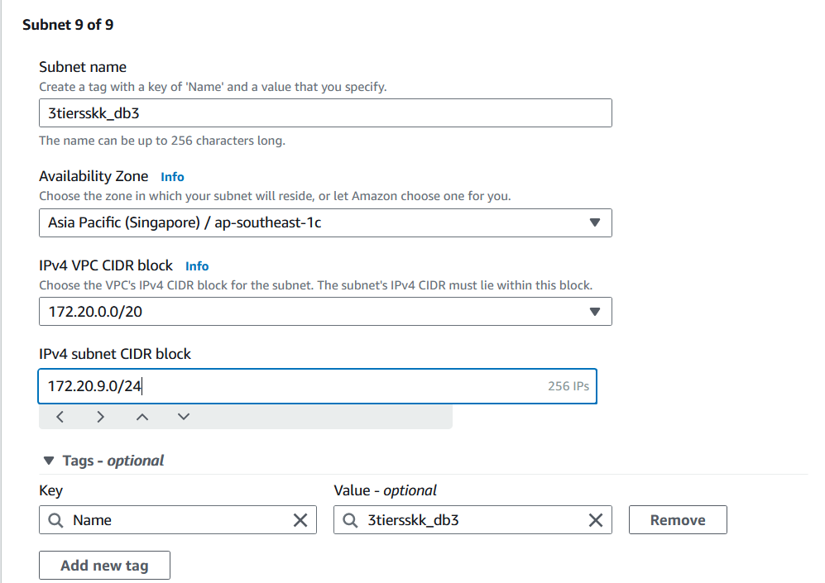

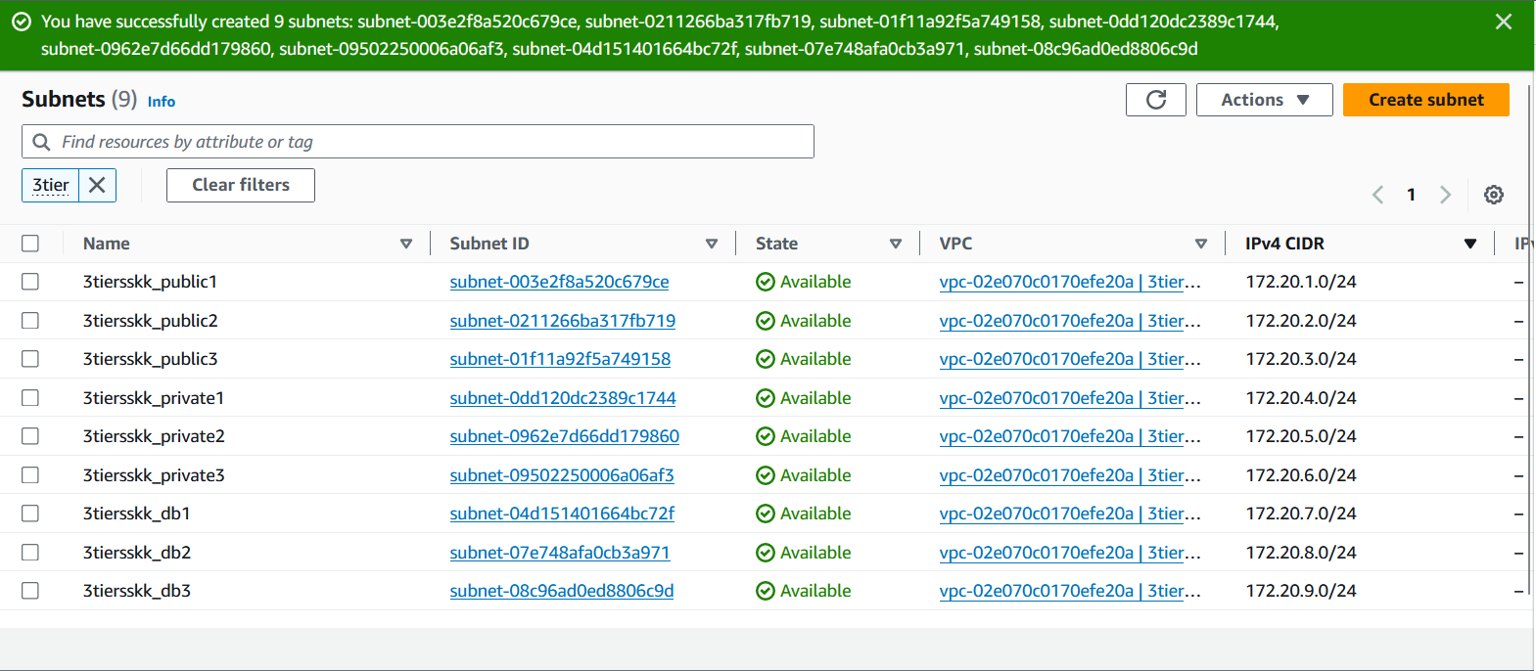

|  |  |
| --- | --- |
| **Configuration of Subnets** | |
| Number of Public subnets | 03 |
| Number of Private subnets (For private instances) | 03 |
| Number of Private subnets (For database) | 03 |

* 1. **Internet Gateway setup for public subnet**
* Go to the internet gateway section in the VPC dashboard.
* Create a new internet gateway and attach it to your VPC.

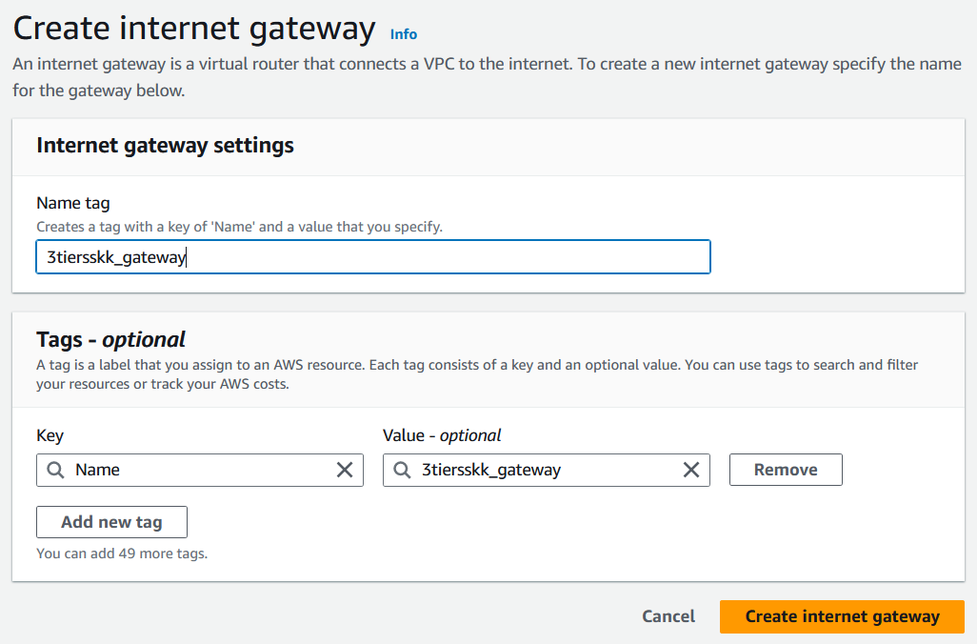

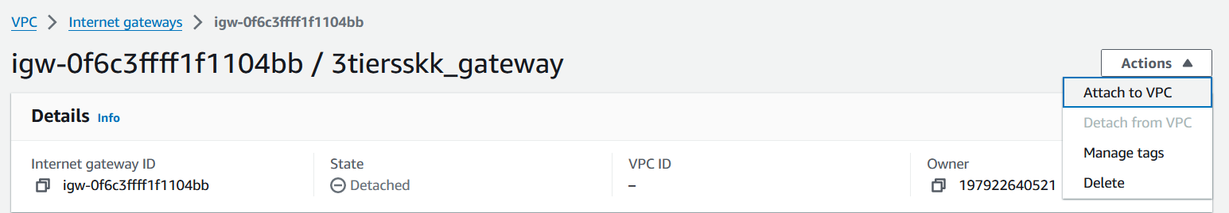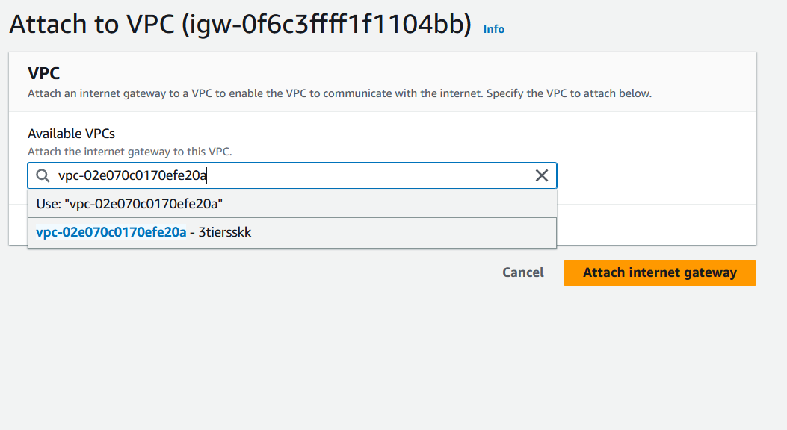

* 1. **NAT Gateway setup for private subnet**
* In the NAT gateway section of the VPC dashboard, create a new NAT gateway.
* Choose a subnet (preferably public) and allocate an Elastic IP address for the NAT gateway.

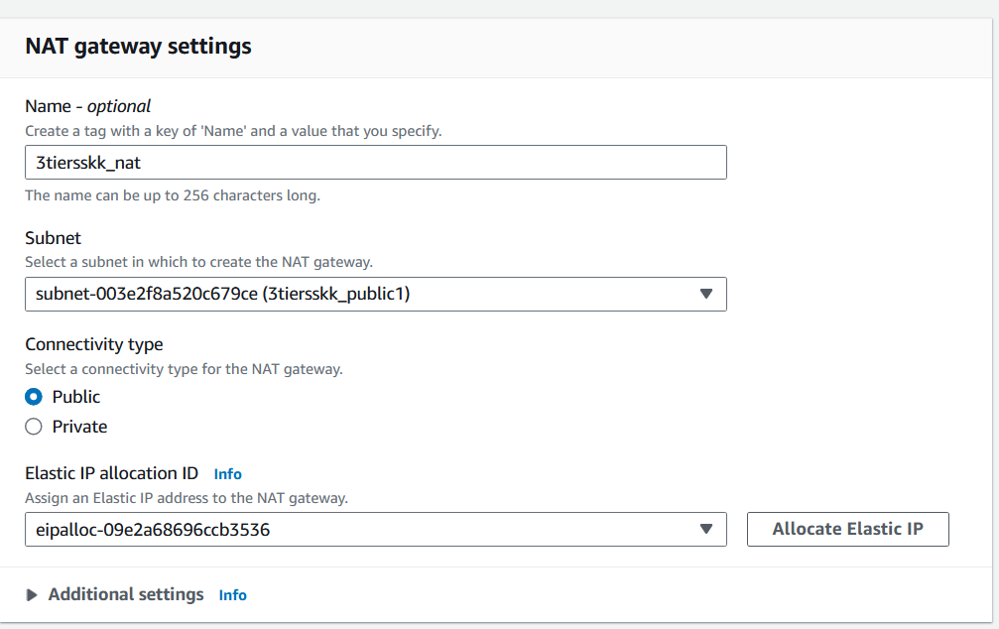

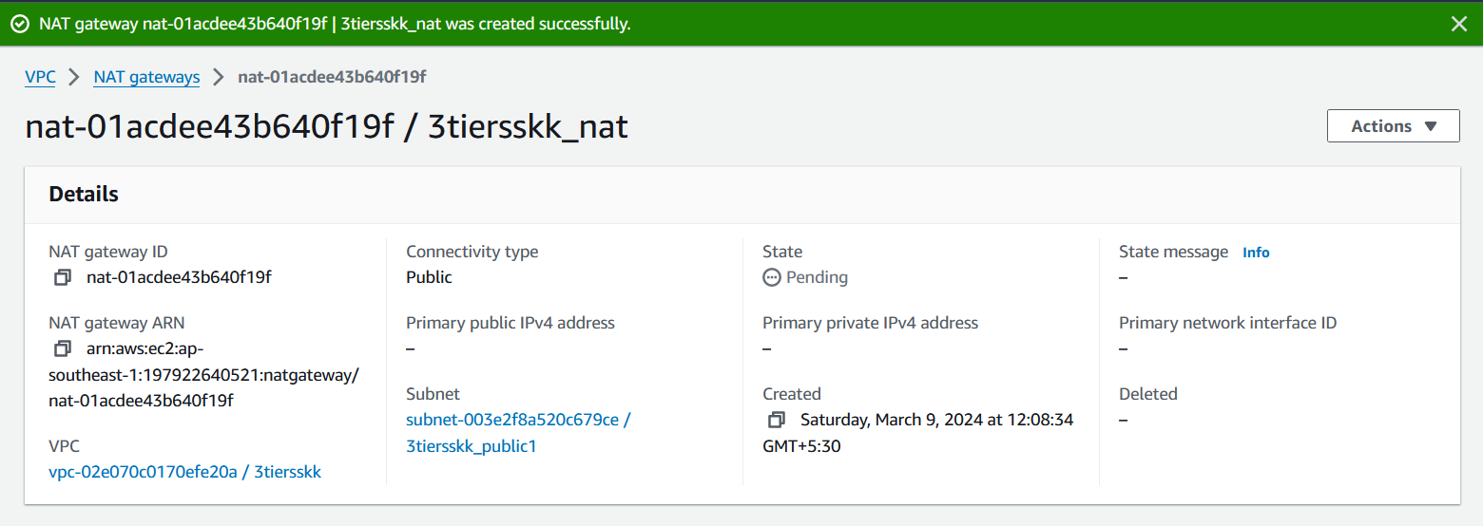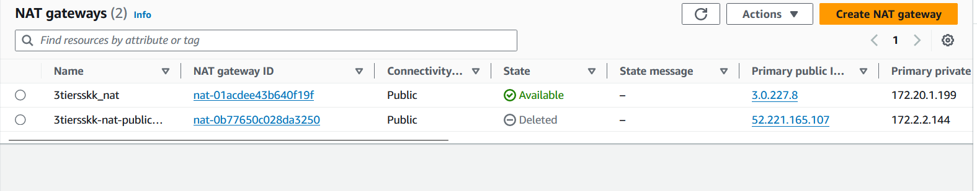

* 1. **Routing tables configuration**
     1. **Create route tables (for public and private subnets)**

• Select the VPC that you created or want to associate this route table with.

• Click on "Create" to create the route table

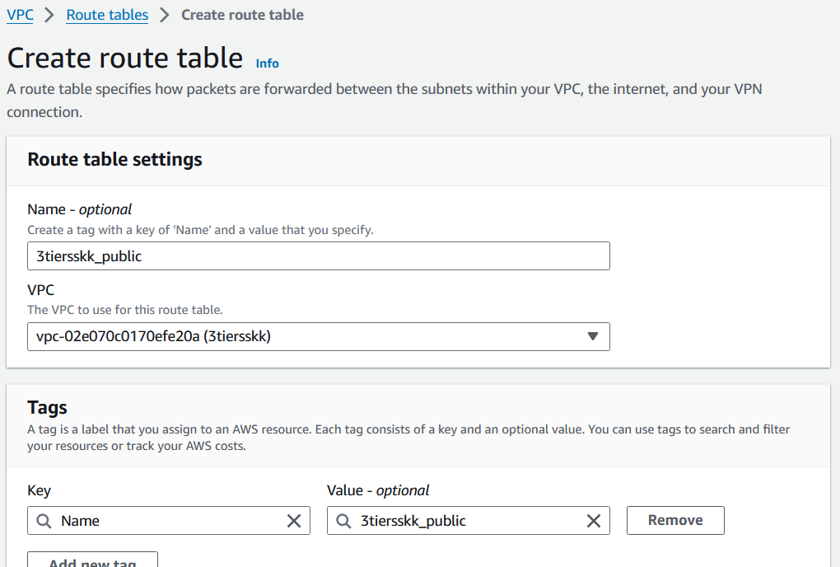

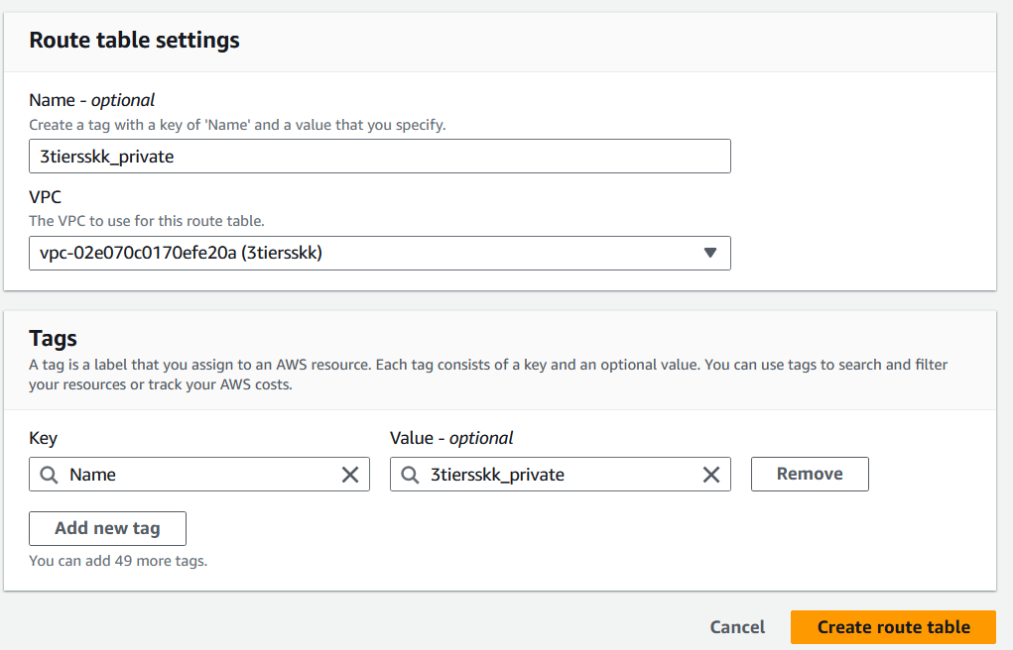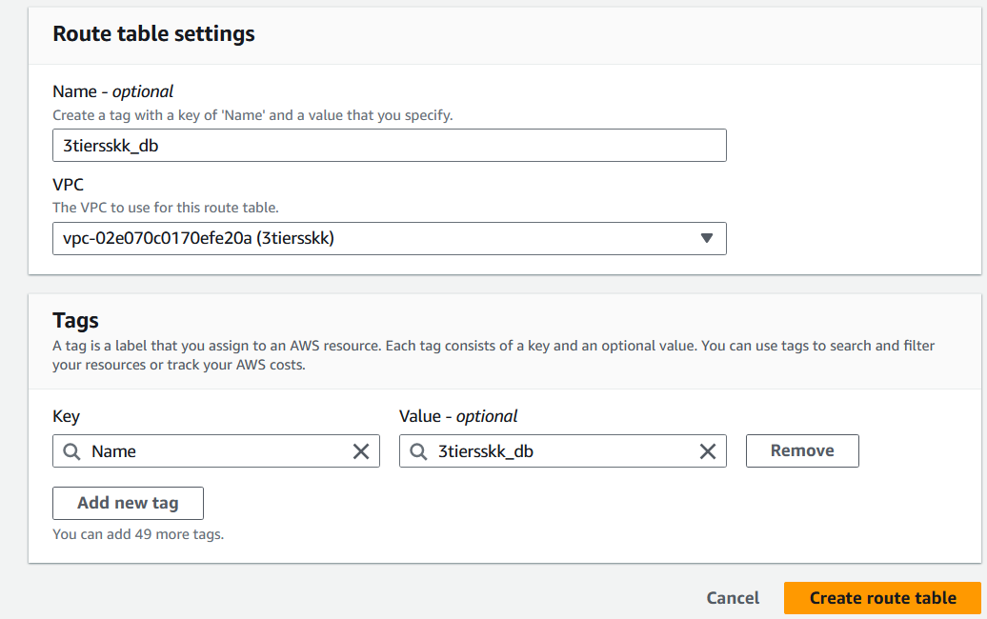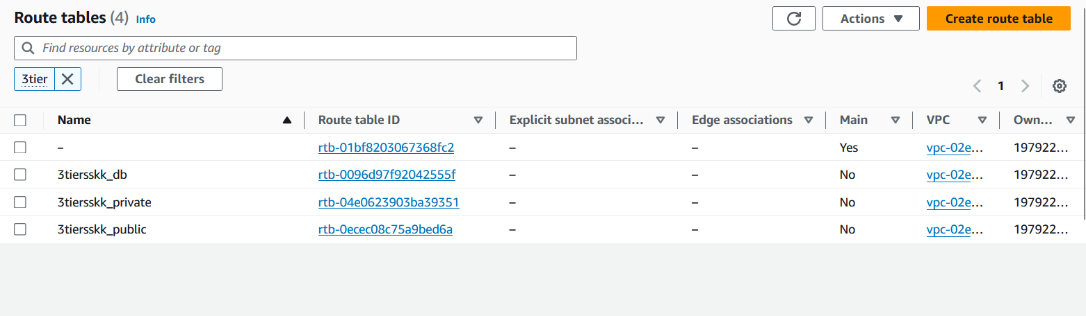

* + 1. **Associate route tables with subnets**
* After creating the route table, select it from the list of route tables.
* Click on the "Subnet Associations" tab.
* Click on the "Edit subnet associations" button.
* Select the public subnet(s) that you want to associate with this route table.
* Click on "Save"

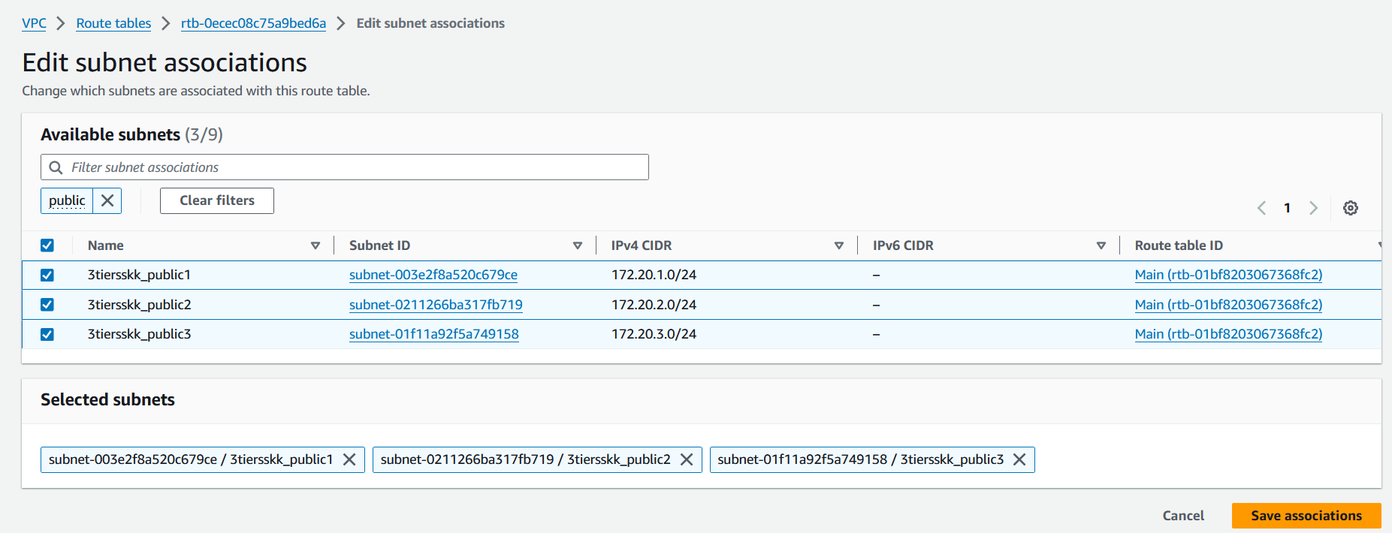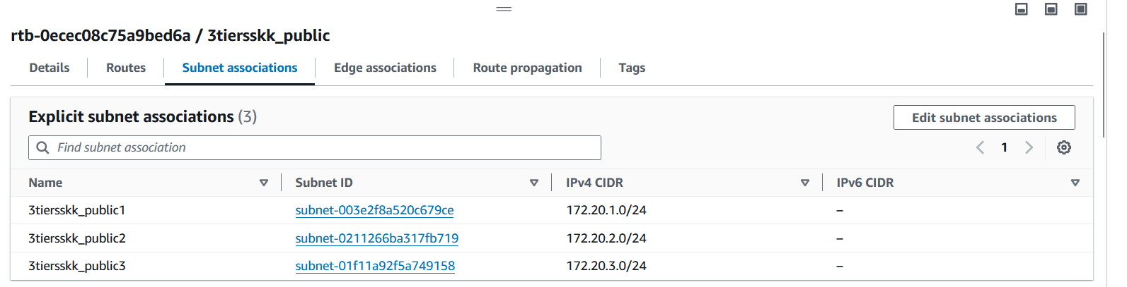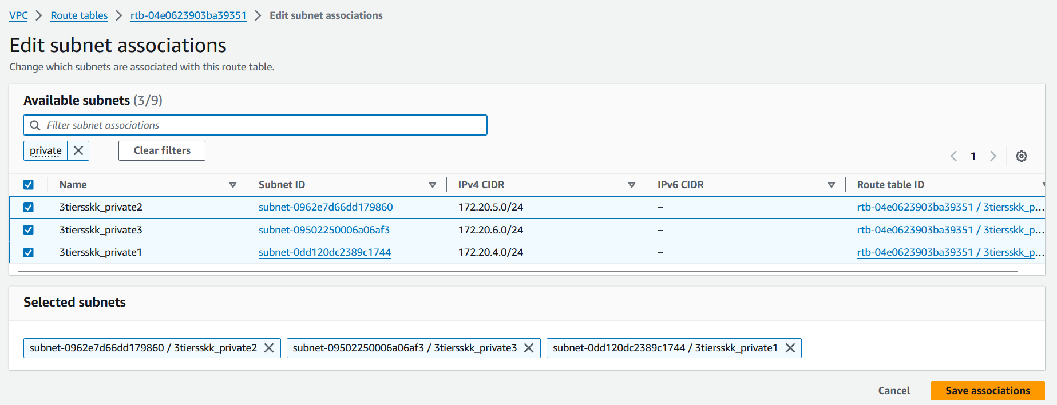

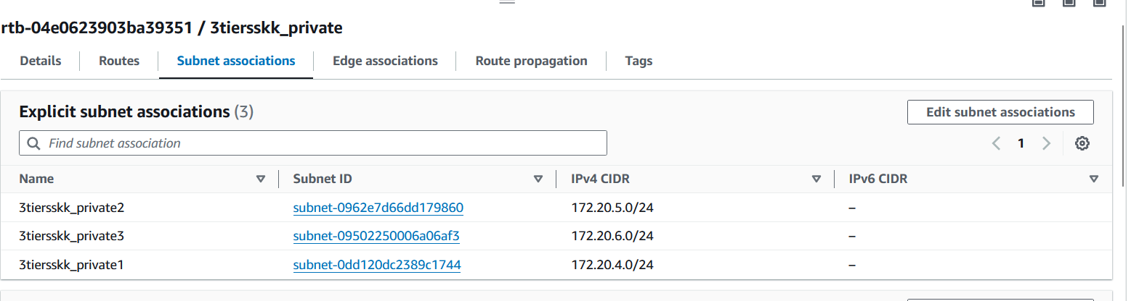

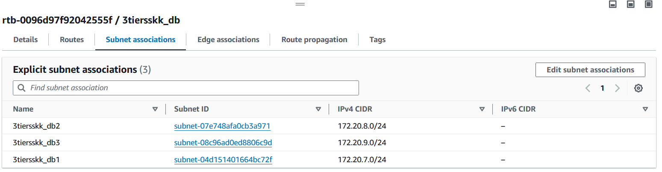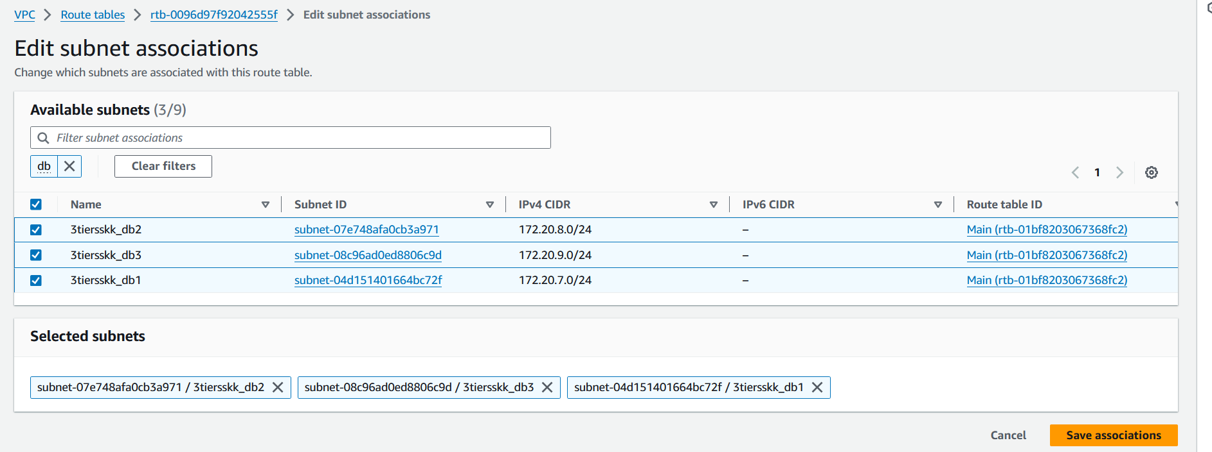

* + 1. **Edit route tables**

• **Public Subnet Route Table:**

* + In the route table associated with the public subnet:
  + Add a route for internet-bound traffic (0.0.0.0/0) pointing to the internet gateway.
  + This allows instances in the public subnet to access the internet.

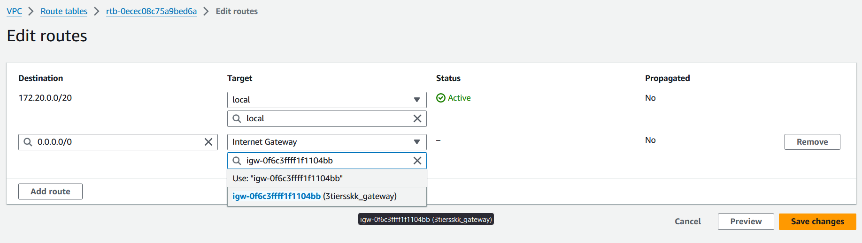

• **Private Subnet Route Table:**

* + In the route table associated with the private subnet:
  + Add a route for internet-bound traffic (0.0.0.0/0) pointing to the NAT gateway.
  + This enables instances in the private subnet to access the internet through the NAT gateway.

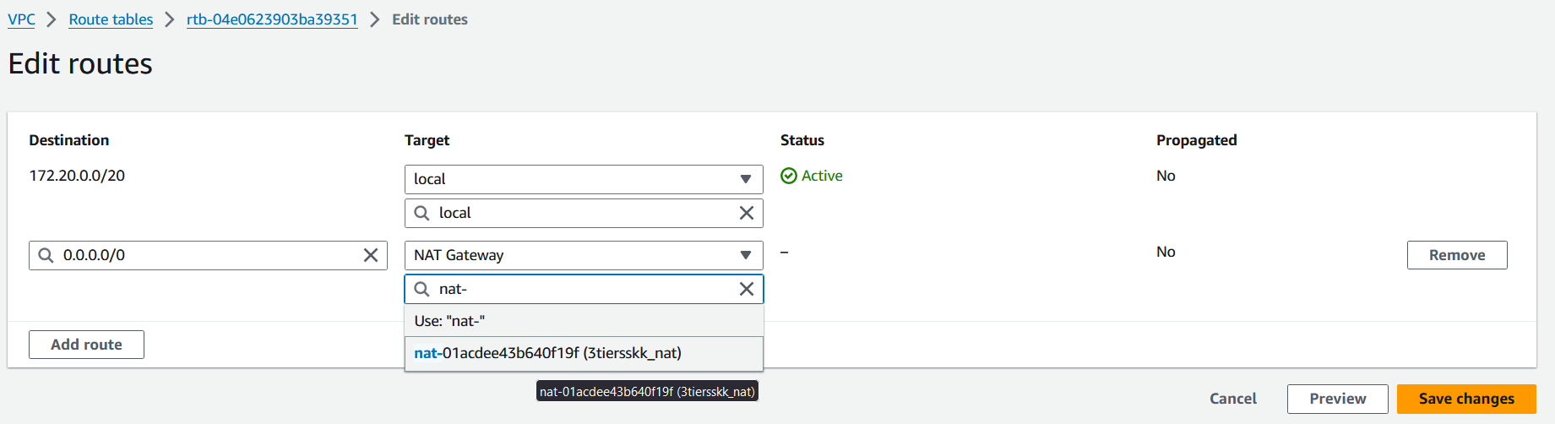

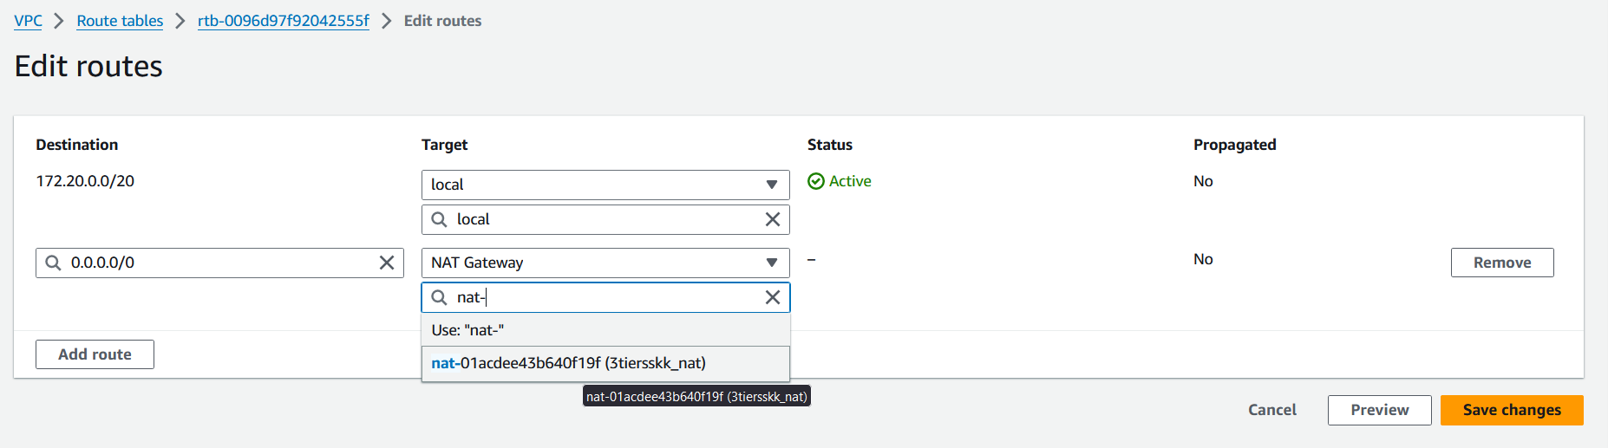

* 1. **Security measures (Security Groups)**
     1. **Create security groups**

**Security Group for Public Subnet**

• Select the VPC that your public subnet is part of.

• In the "Inbound rules" section, define rules to allow inbound traffic to your public resources.

• Leave the "Outbound rules" section open to allow all outbound traffic by default.

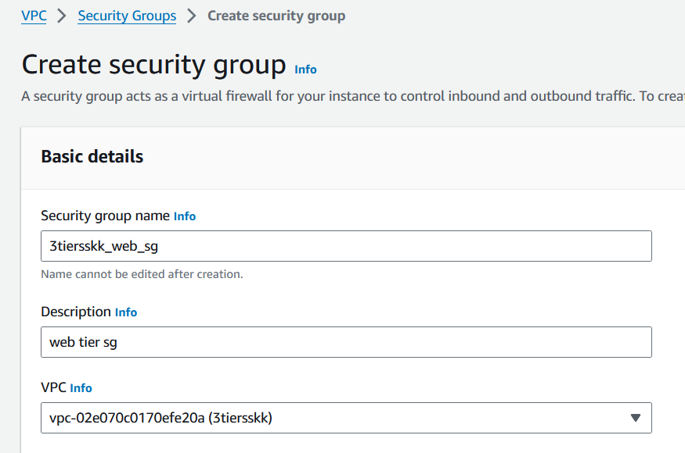

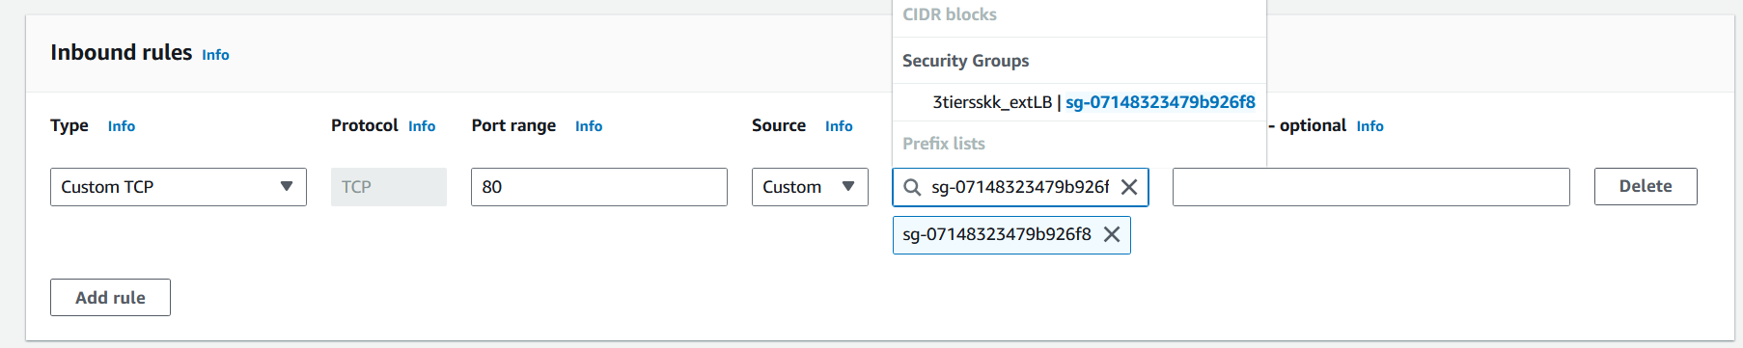

**Security Group for Private Subnet**

• Select the same VPC that your private subnet is part of.

• Define inbound rules to allow the public subnet security group to communicate with private subnet, avoid internet traffic for security purposes.

• Leave outbound rules open to allow all outbound traffic by default.

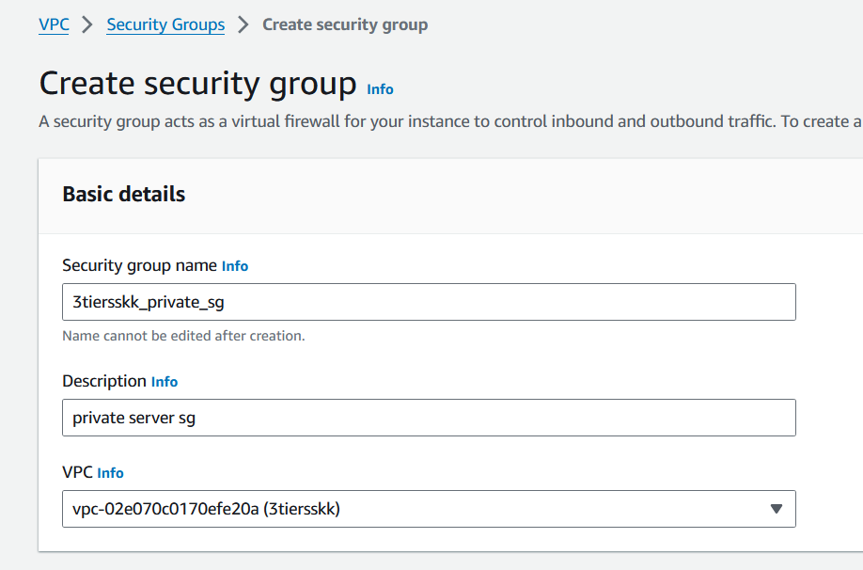

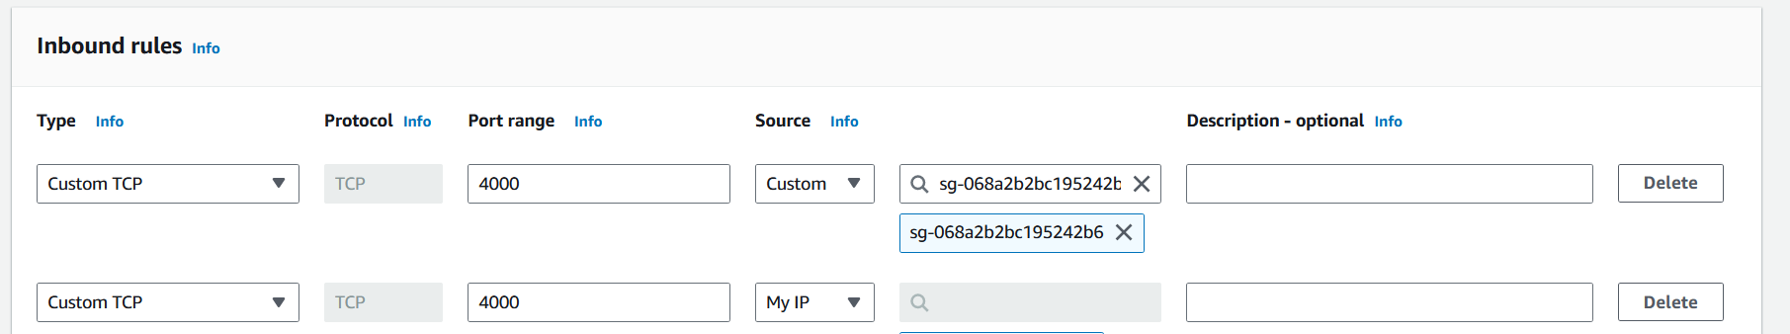

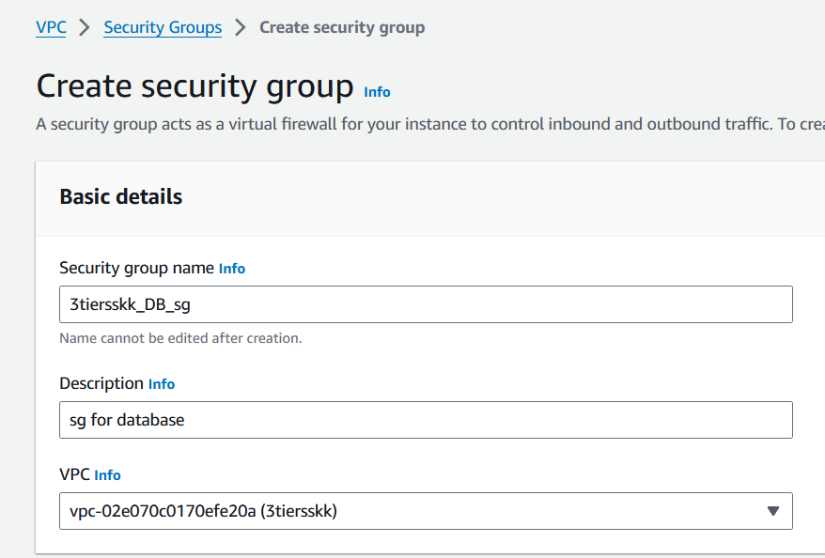

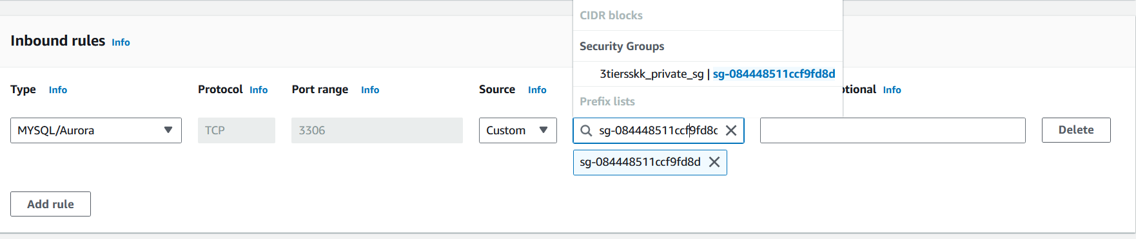

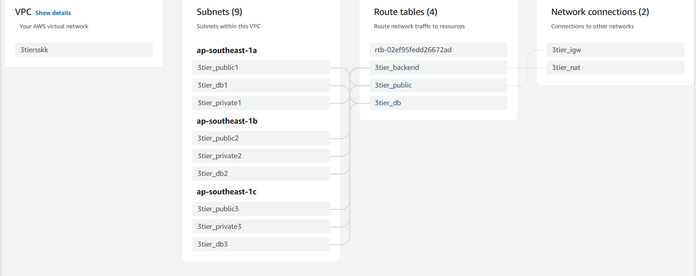

1. **Frontend Tier**
   1. **Creation of the EC2 instance in the public subnet**

* Go to the EC2 Dashboard
* Launch Instance

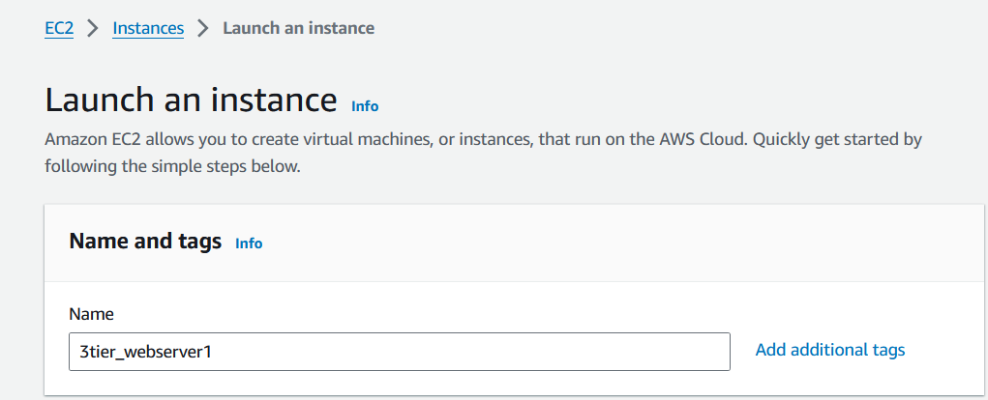

* Choose an Amazon Machine Image (AMI)

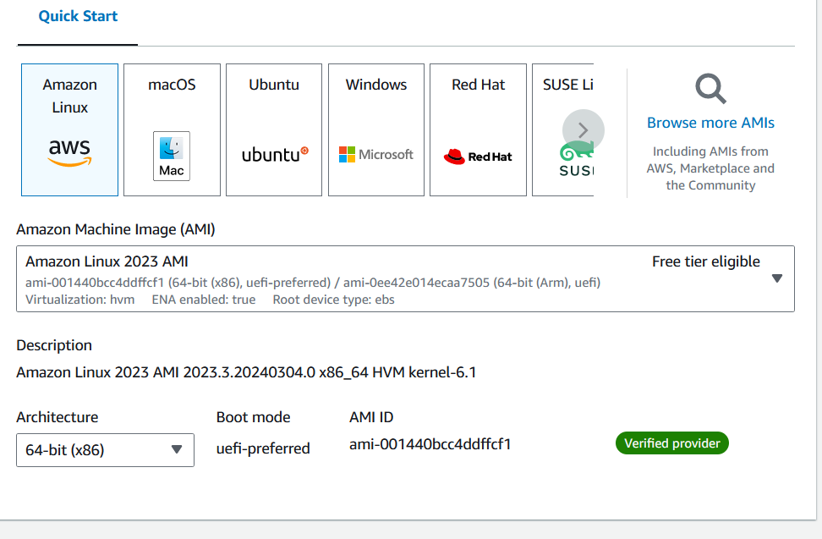

* Choose an Instance Type

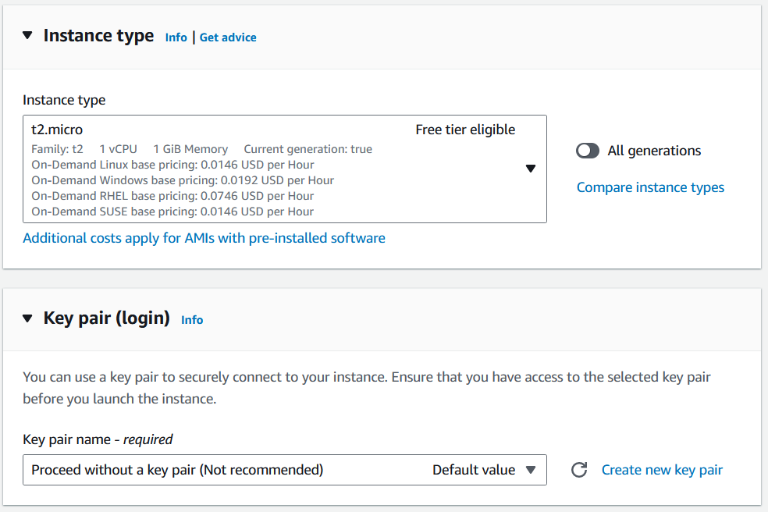

* Configure Instance Details , Security Group and IAM roles

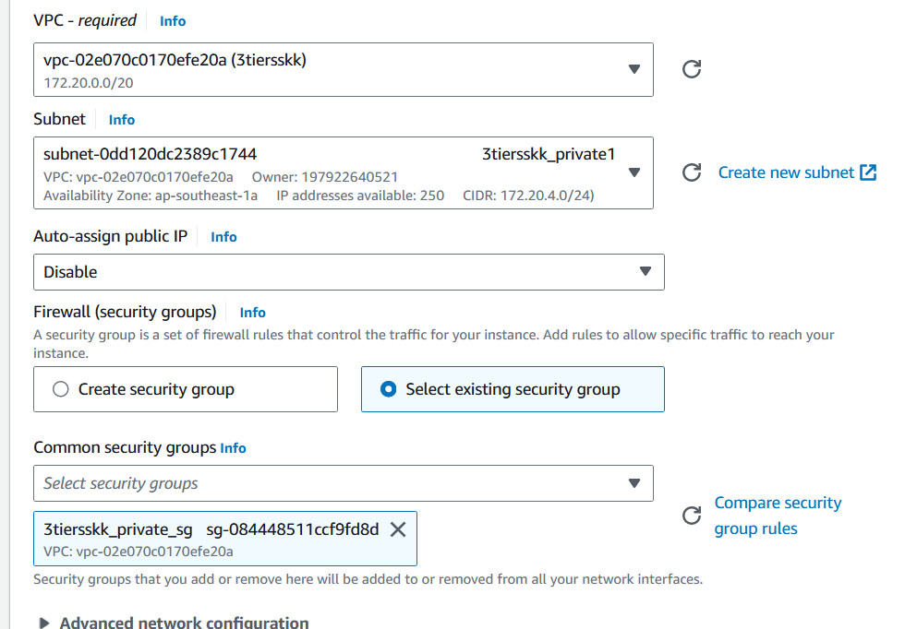

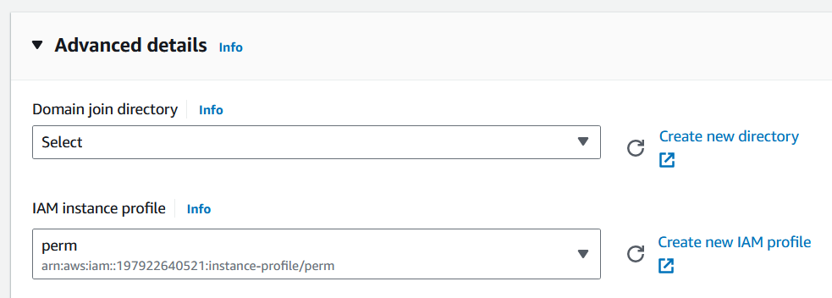

1. **Application Tier**
   1. **Creation of the two EC2 instances in private subnets**

Follow the same steps as above and the keypair should be the same as the keypair for public subnet, this step allows the public subnet to connect with the private instance through ssh.

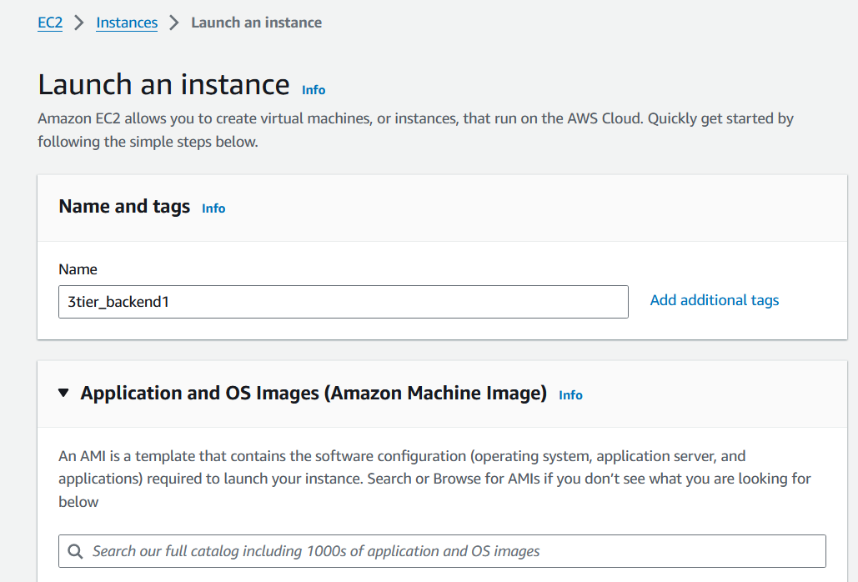

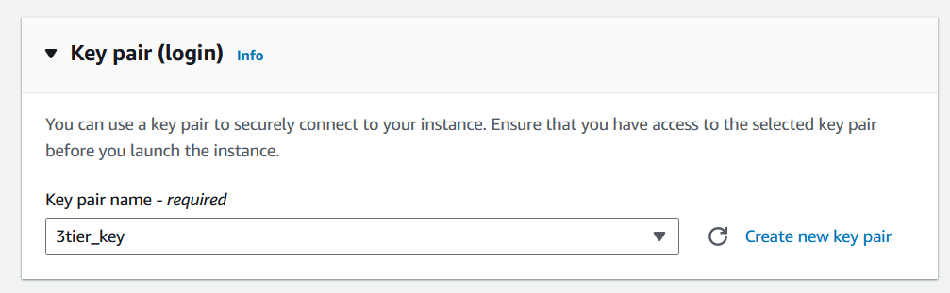

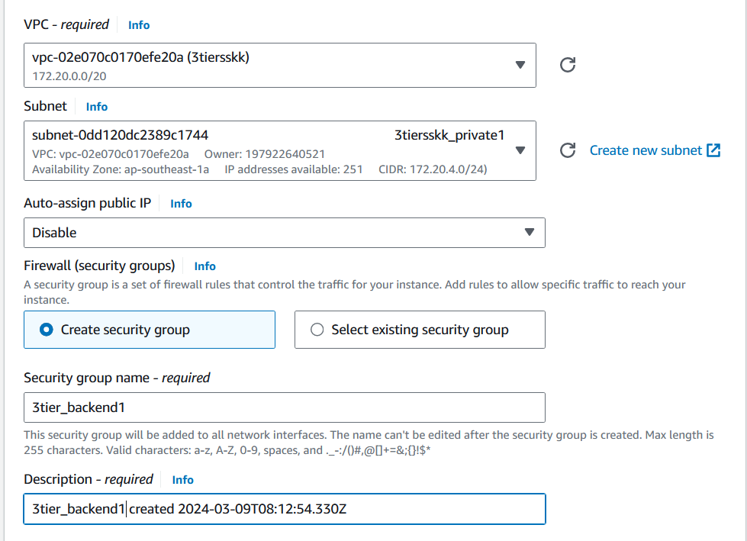

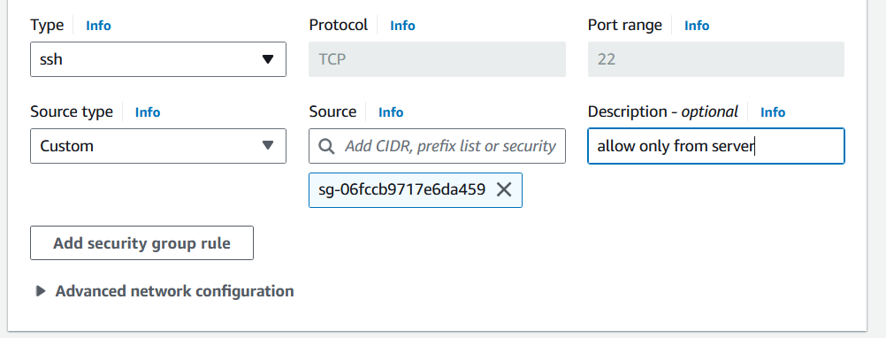

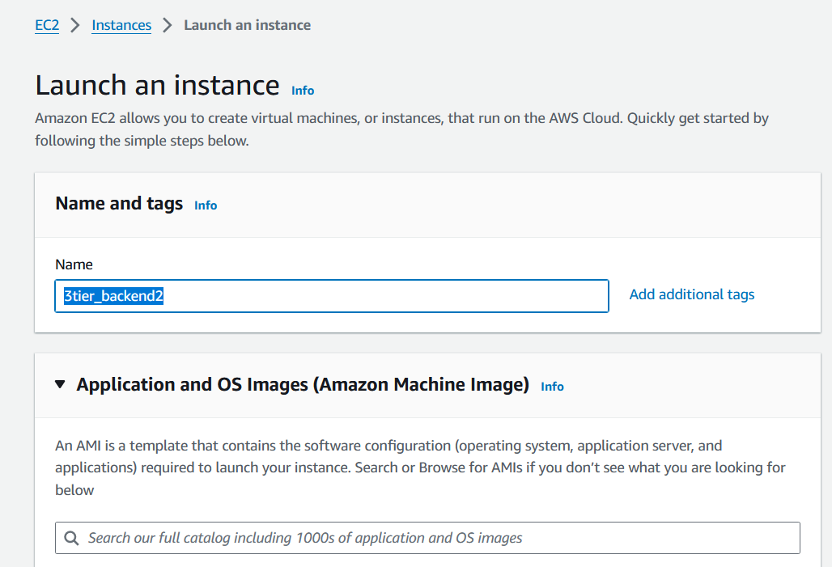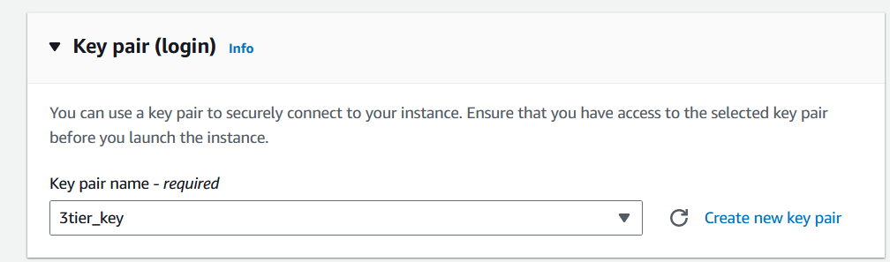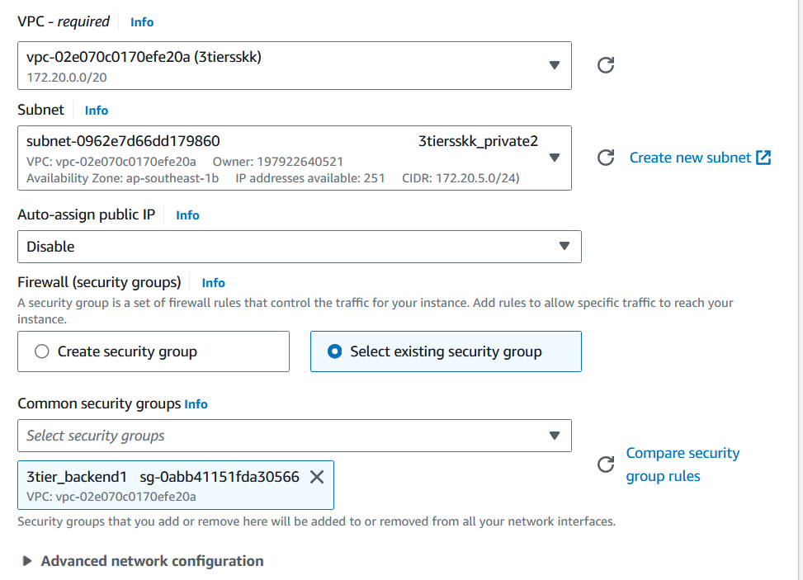

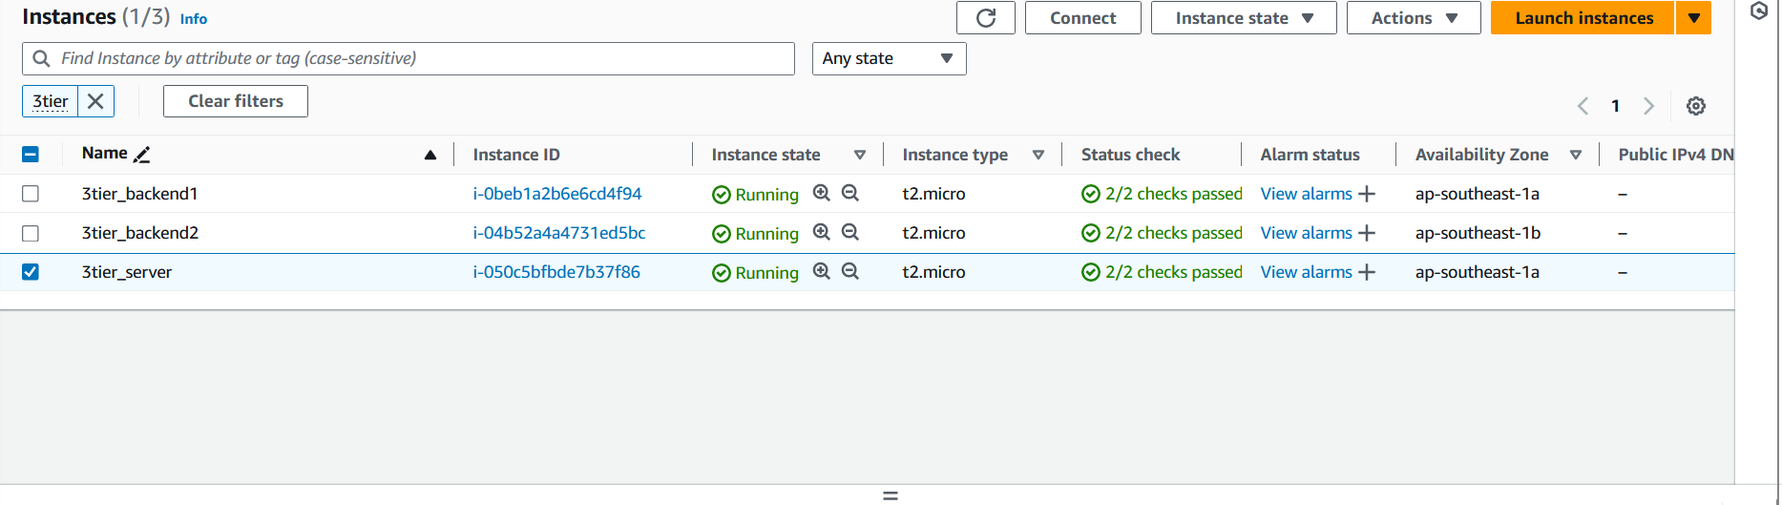

* 1. **Configuring the application tier (business logic, processing)**
* Connect to the public subnet through ssh or Instance connect

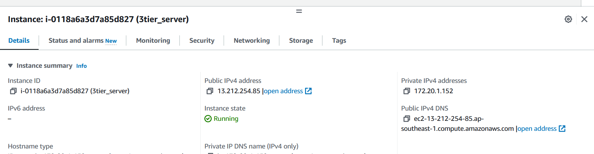

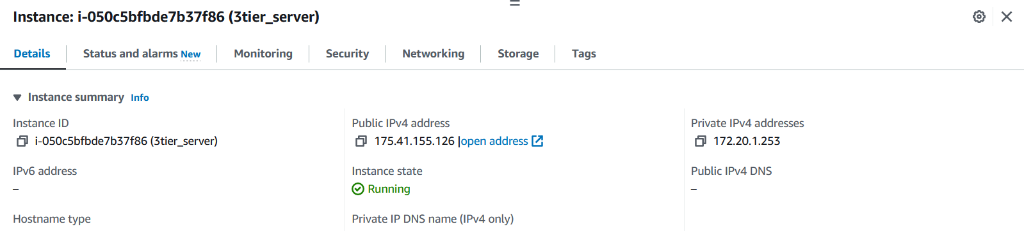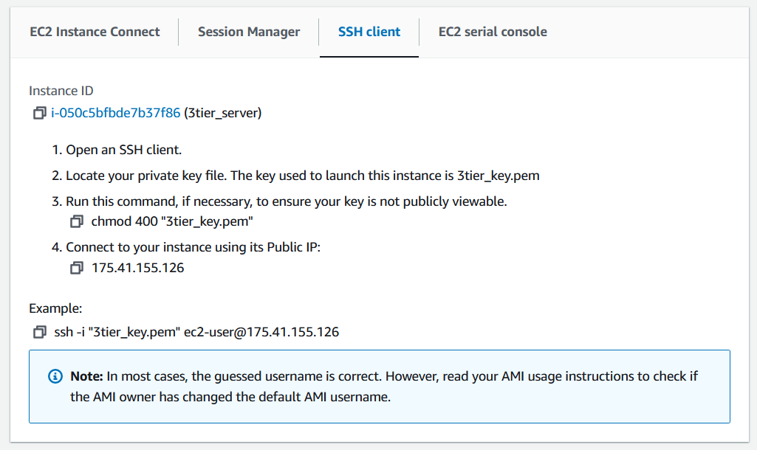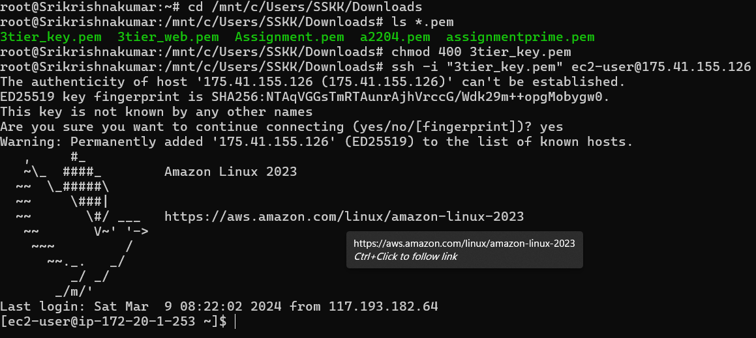

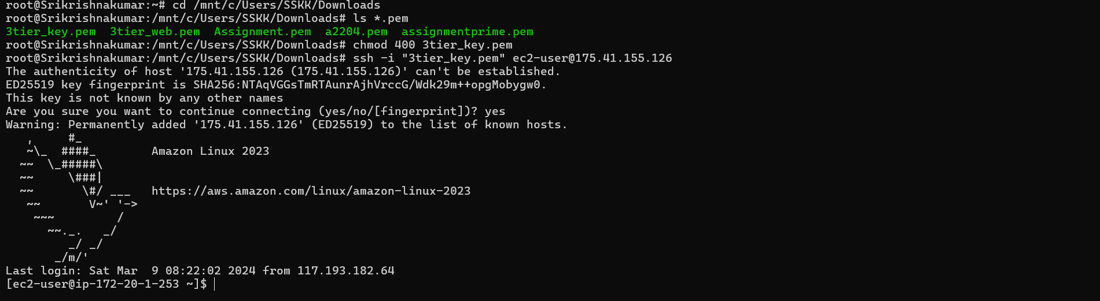

* The keypair is stored in a separate location (S3 bucket) and downloaded to the public subnet. Storing the key in an internet accessible source enables using the key from any location.

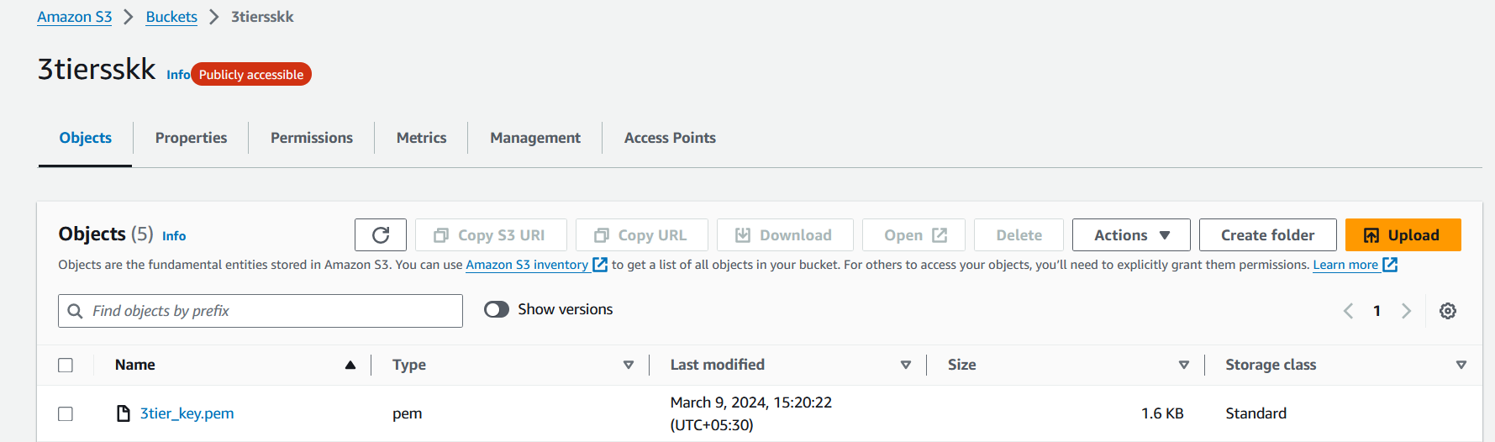

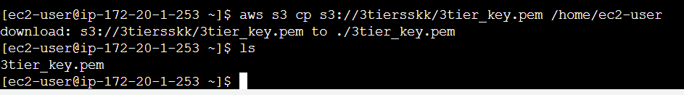

* Connect to the private subnet from public subnet through ssh or Instance connect

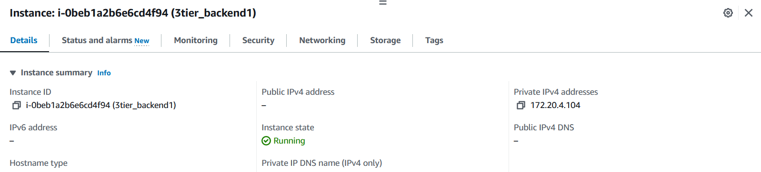

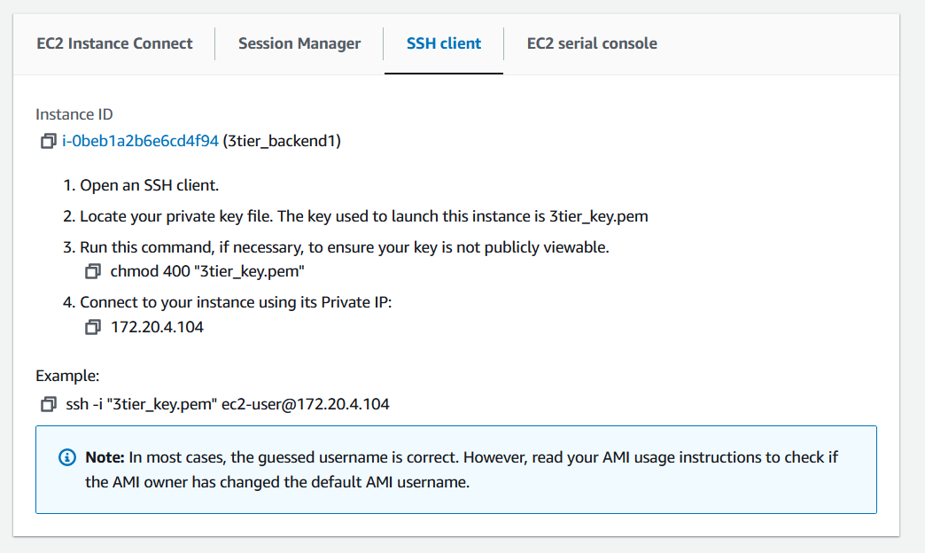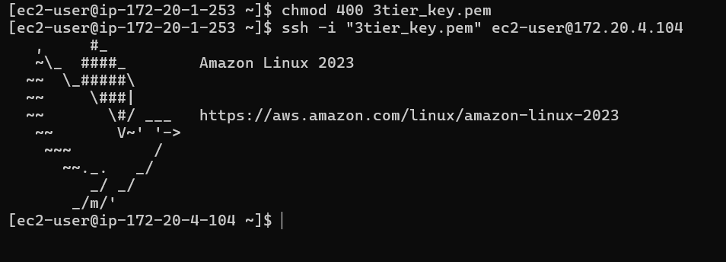

* Update Package Repository

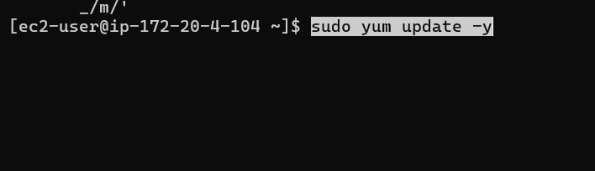

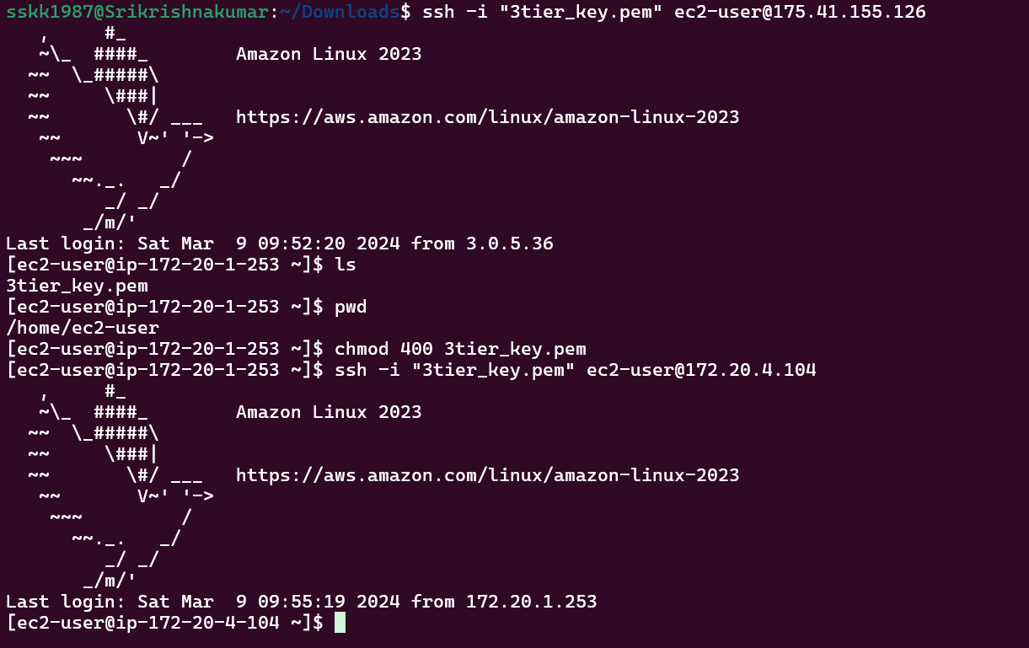

* Install Apache Web Server

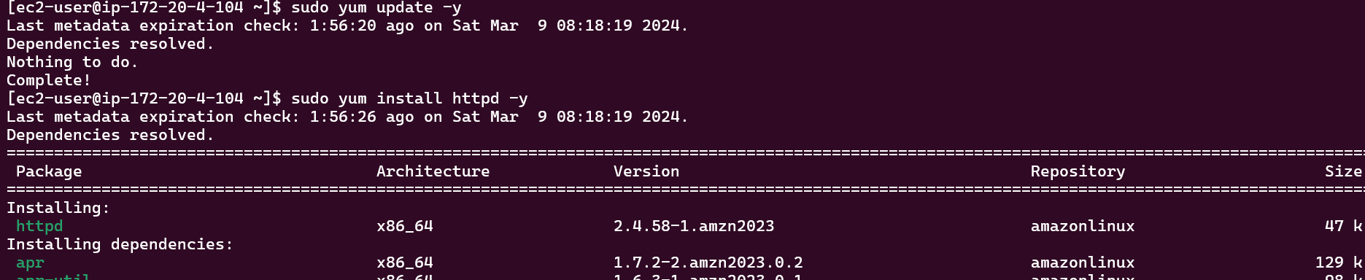

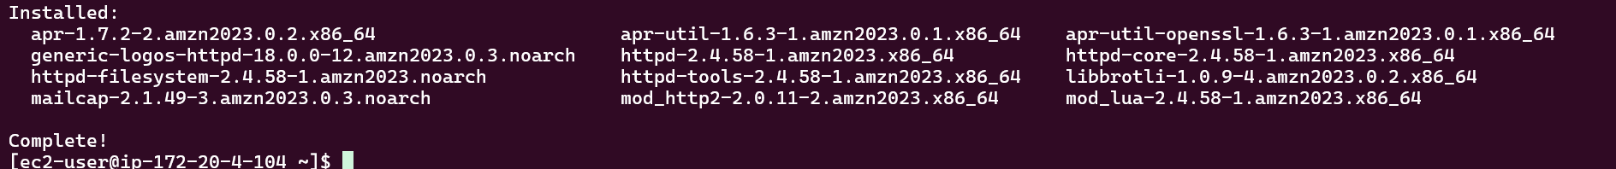

* After installation, start the Apache service and enable it to start on boot:



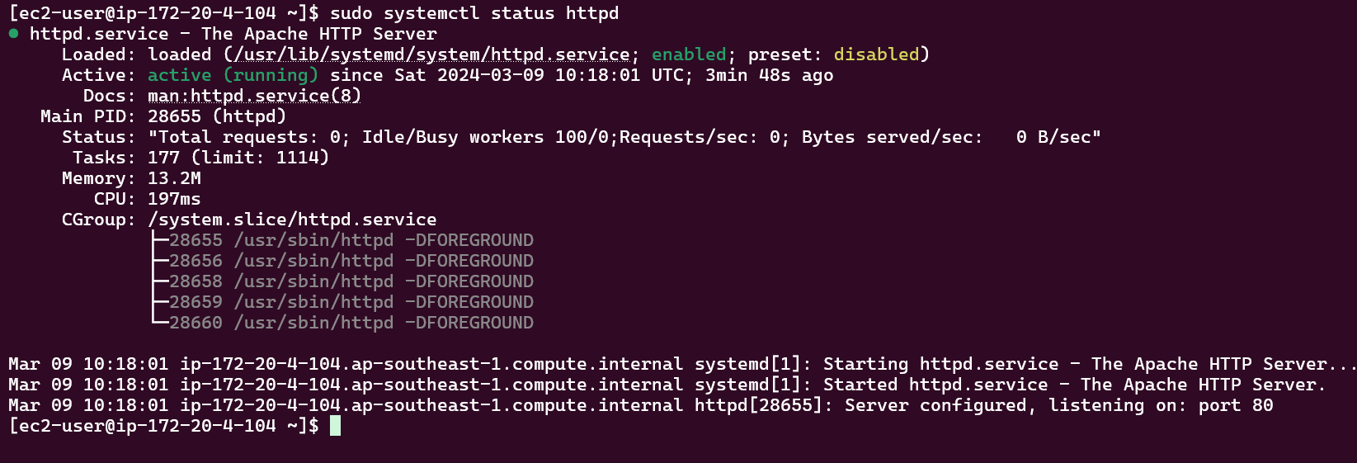

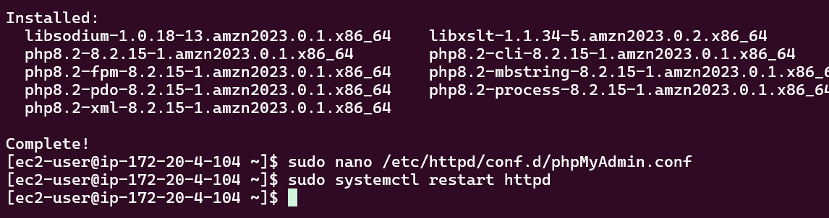

* 1. **Load balancing setup using Application Load Balancers (ALB)**
     1. **Creating the Load balancer**

• Provide a name for your load balancer.

• Select the VPC (Virtual Private Cloud) where you want to deploy the load balancer.

• Choose the availability zones where you want the load balancer to distribute traffic.

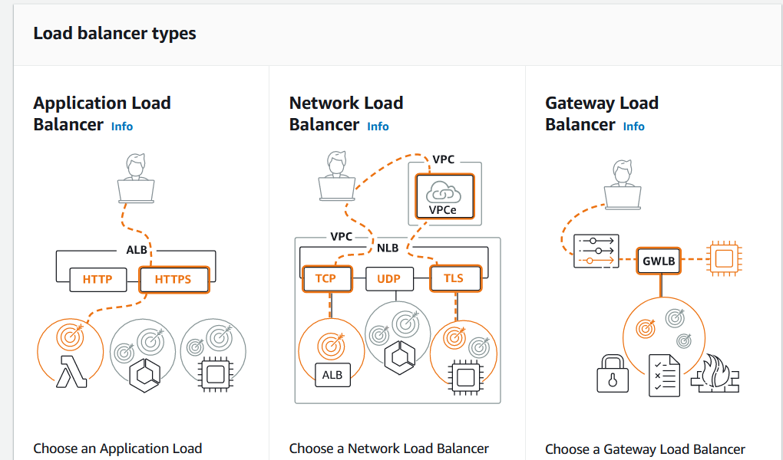

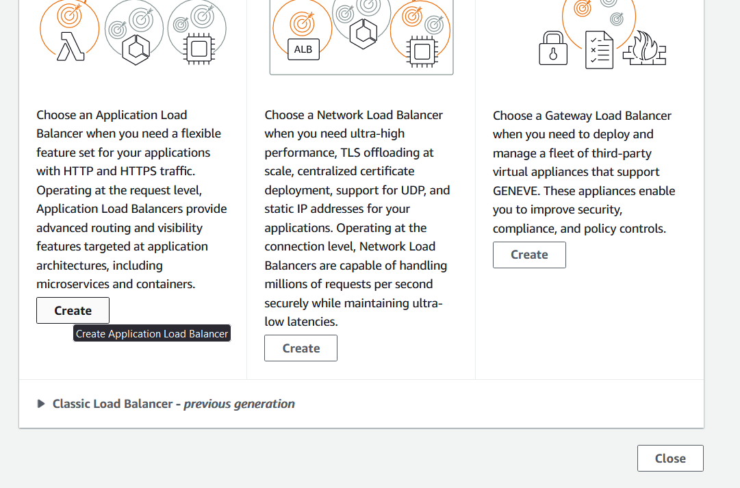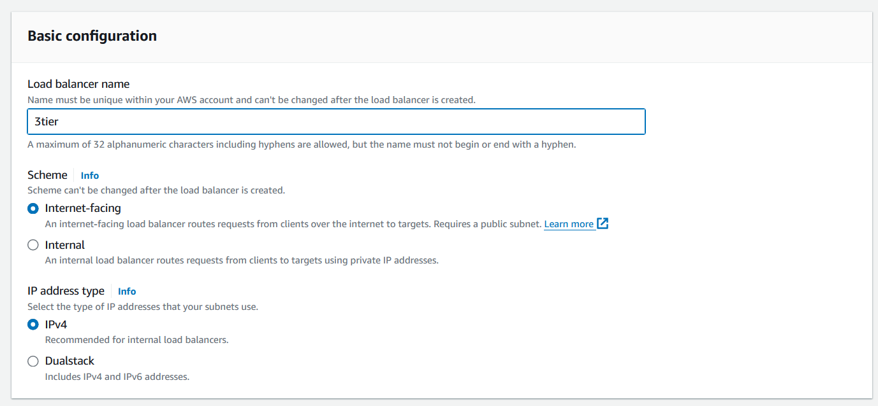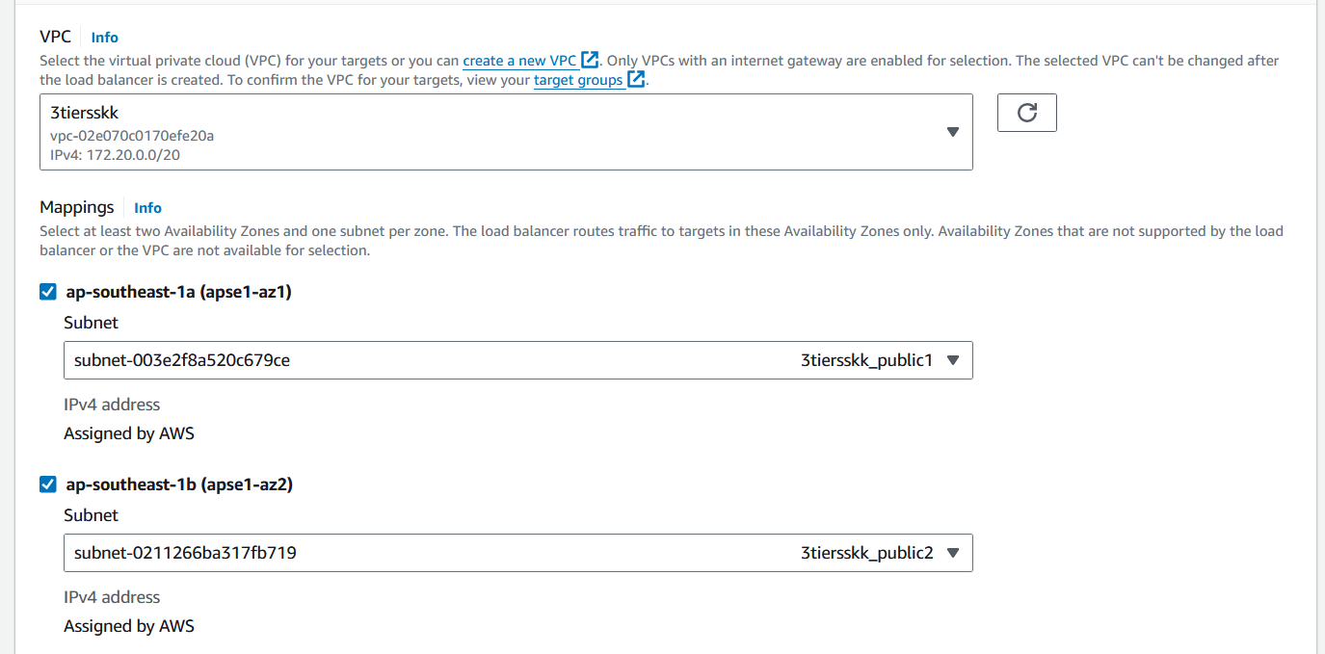

* + 1. **Security group of backend to allow alb**
* Configure security settings for your load balancer, including security groups and whether to enable deletion protection.
* Define target groups and specify the target instances (e.g., EC2 instances) that the load balancer will distribute traffic to.

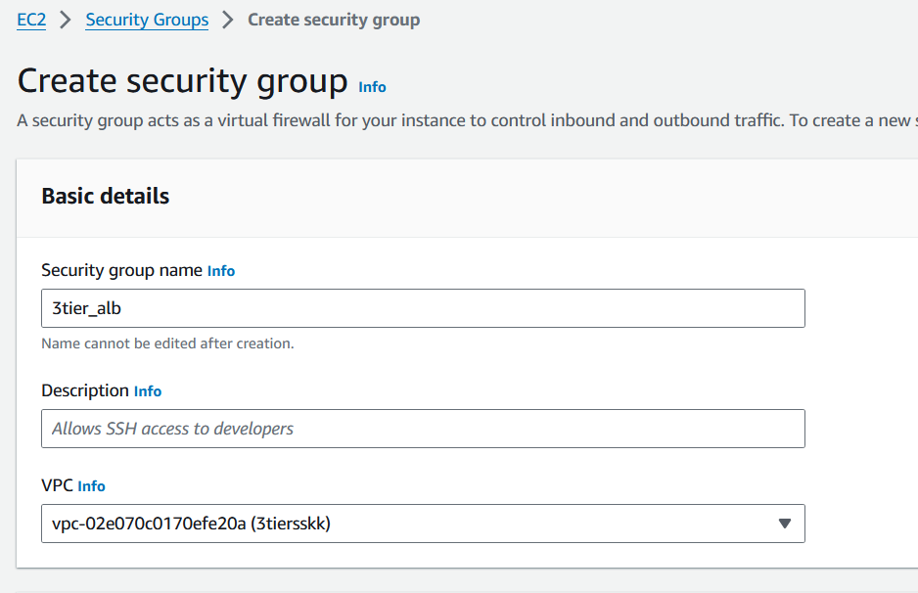

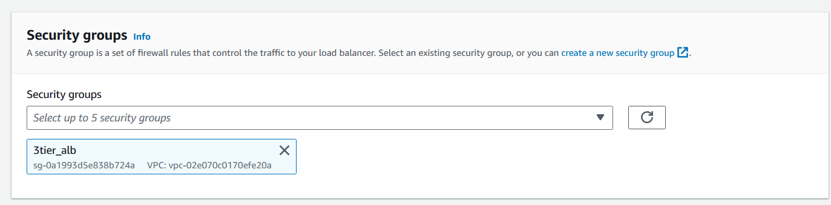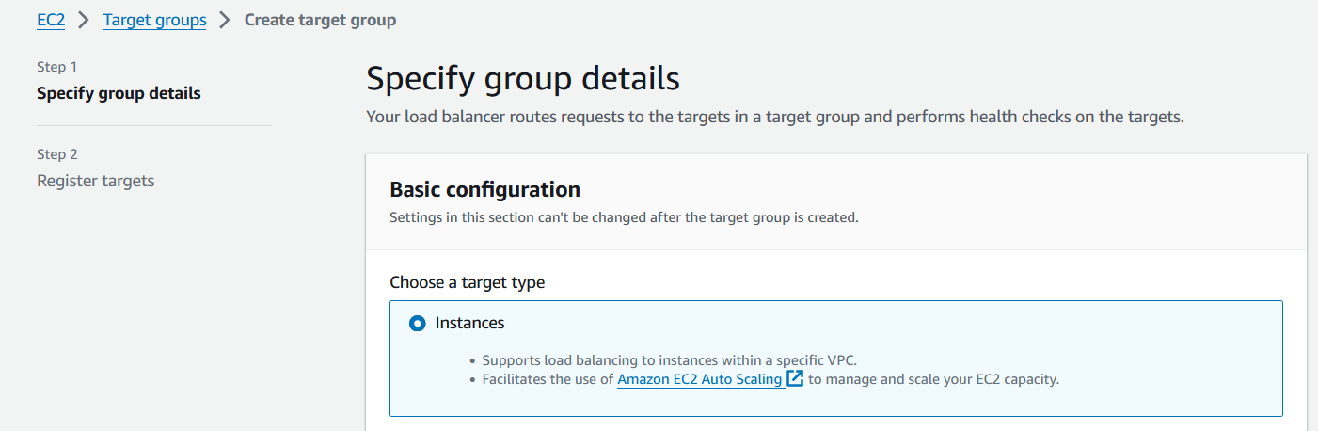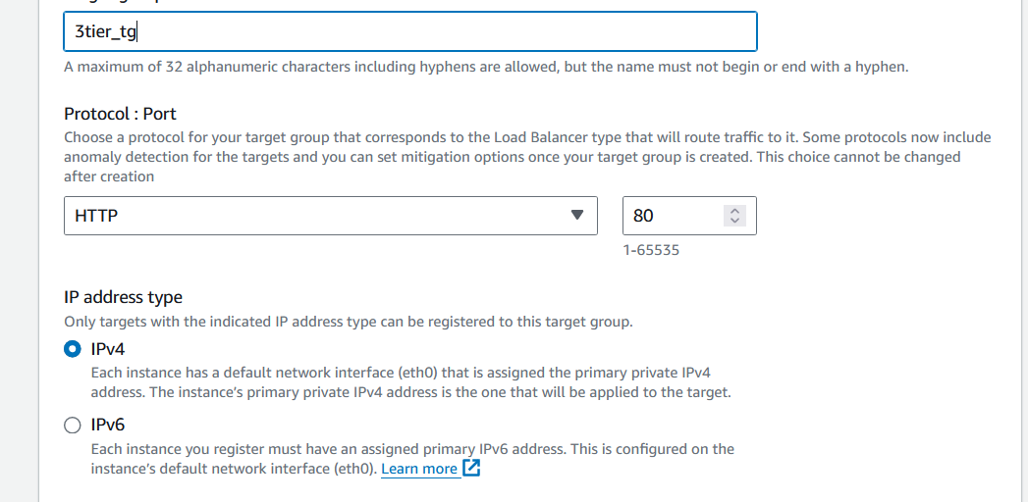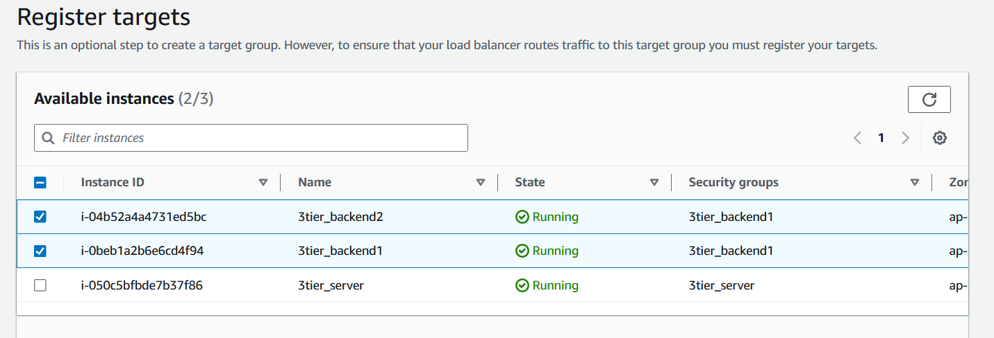

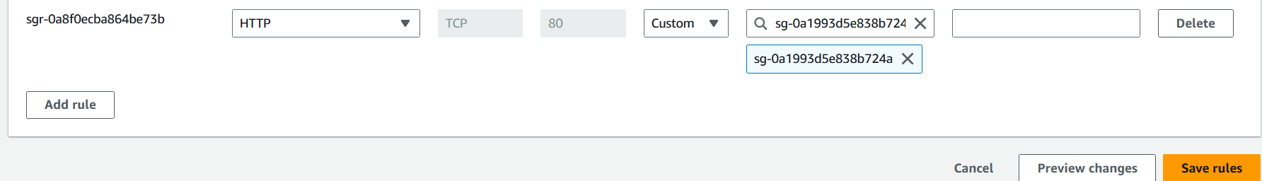

* + 1. **Load balancing between two servers**
* The two private instances has been configured with web servers, now we have created html files to display different text to observe the load balancing between the two instances.

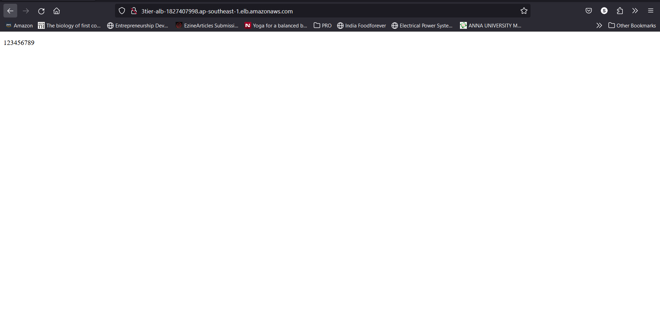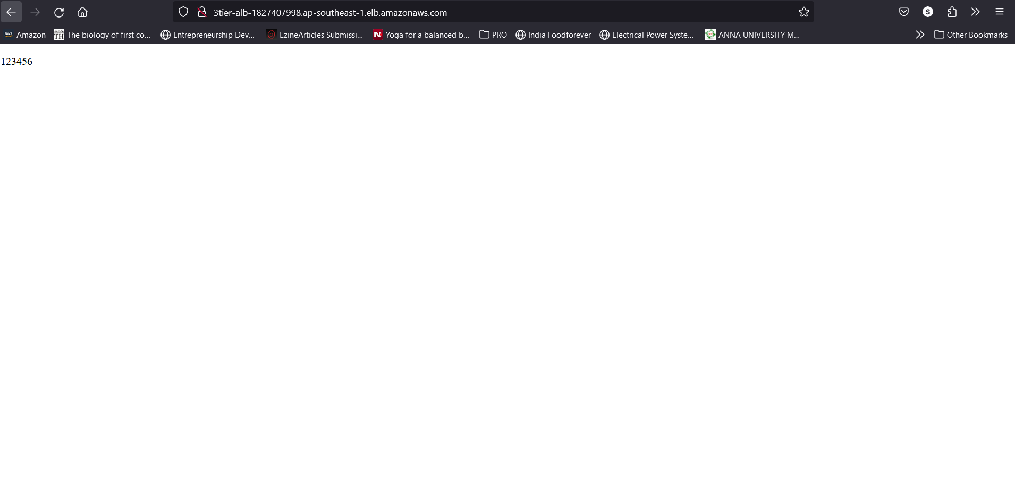

* + 1. **Description of data storage in S3 bucket**
* S3 bucket offers a storage solution, and we use it to store the necessary html, css and javascript needed for websites.

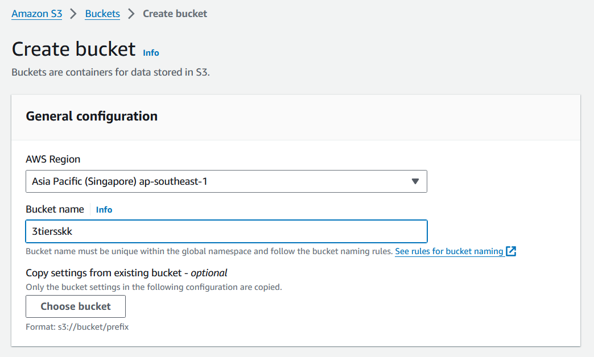

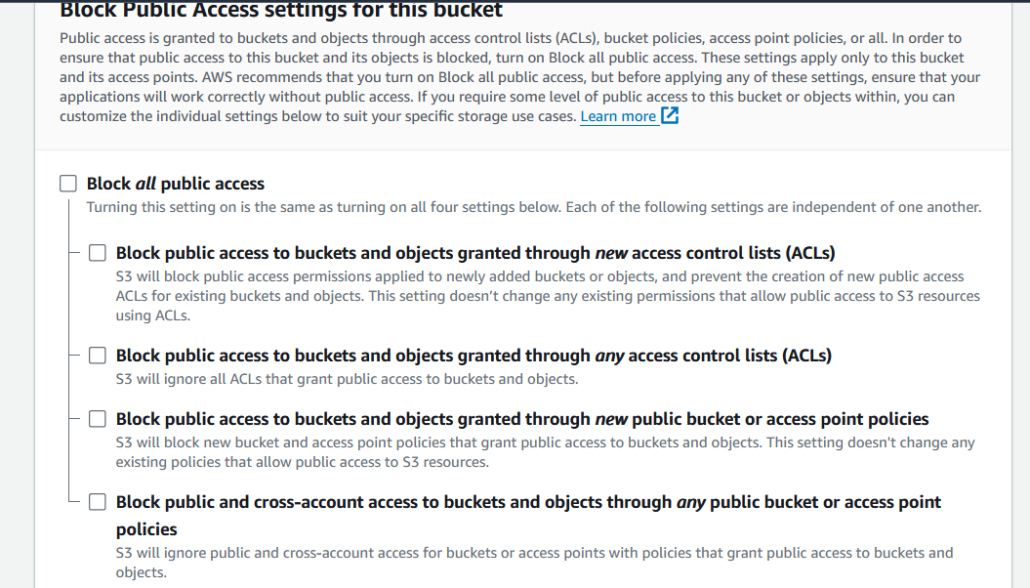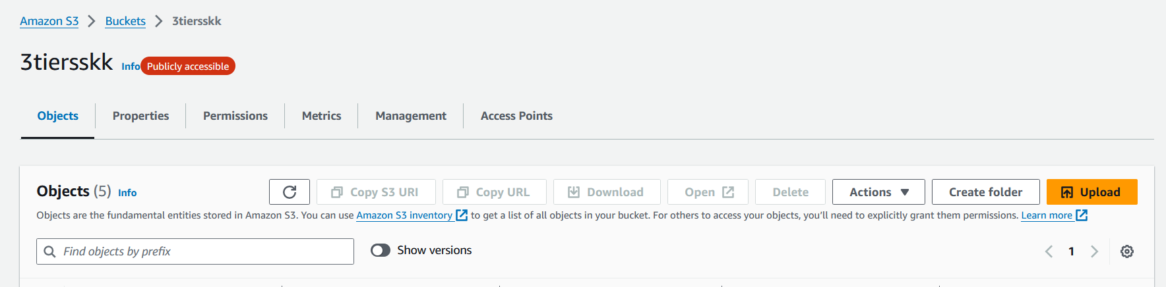

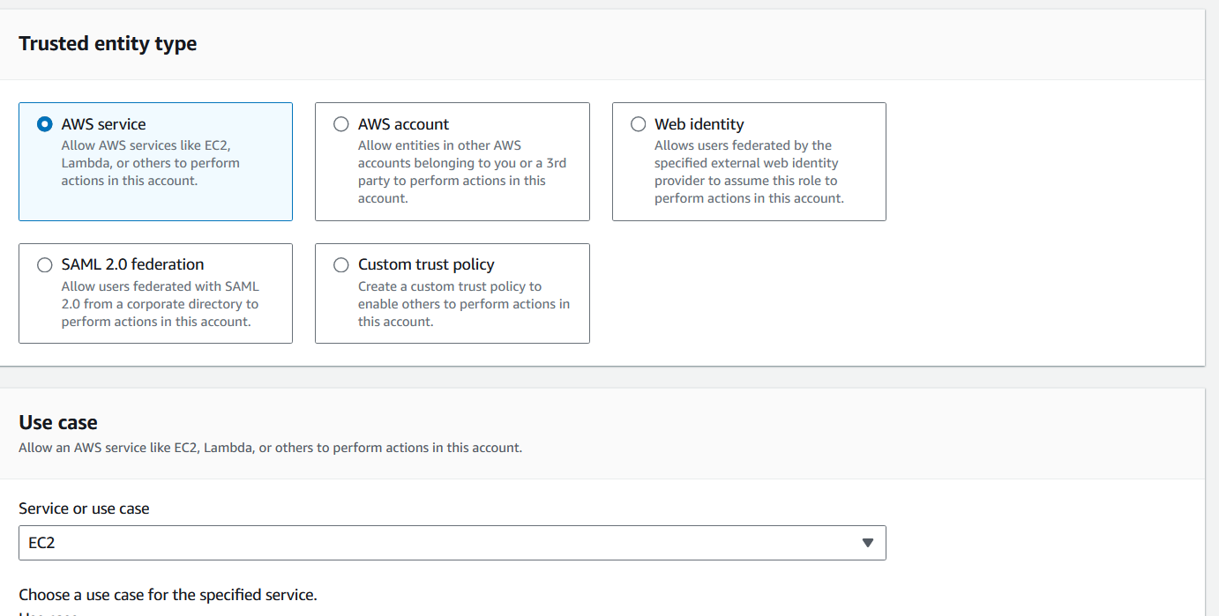

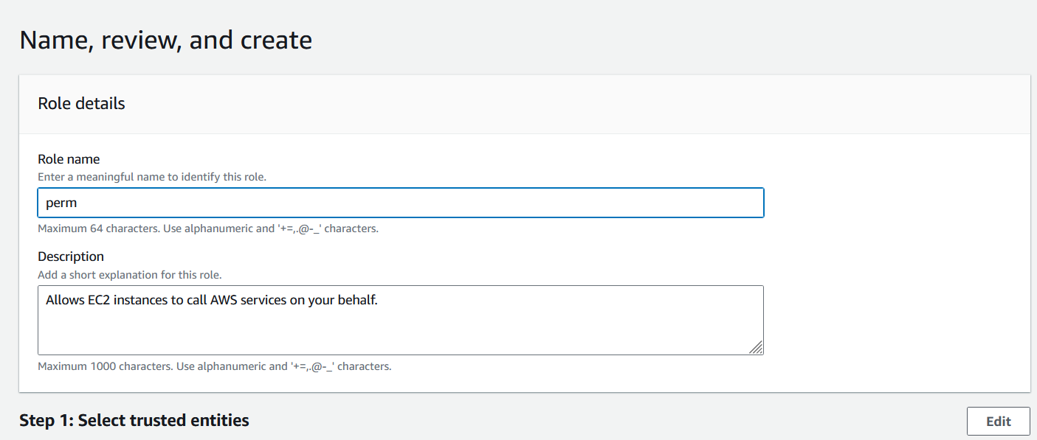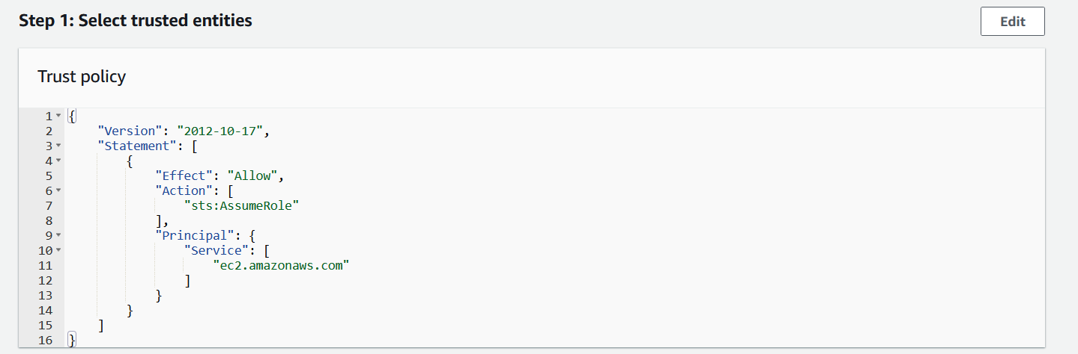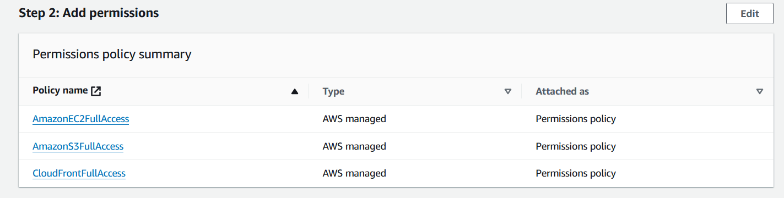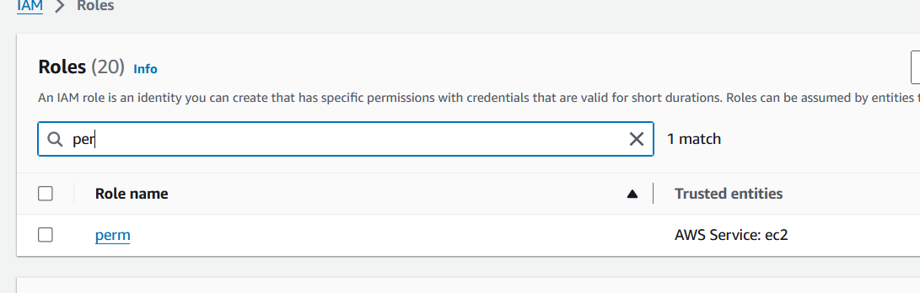

* + 1. **Load balancing between two servers fetching from S3 bucket**
* To observe difference between the servers, the appearance of text in the landing page has been slightly modified.

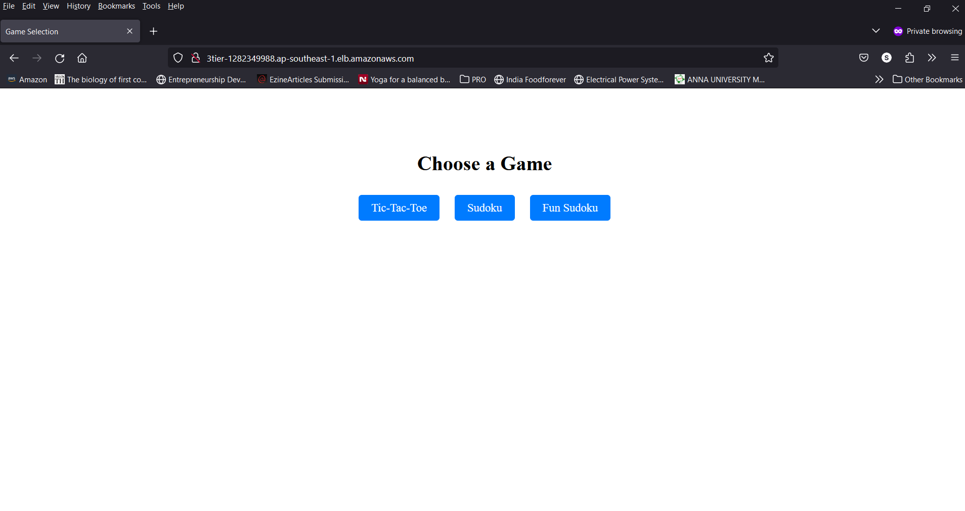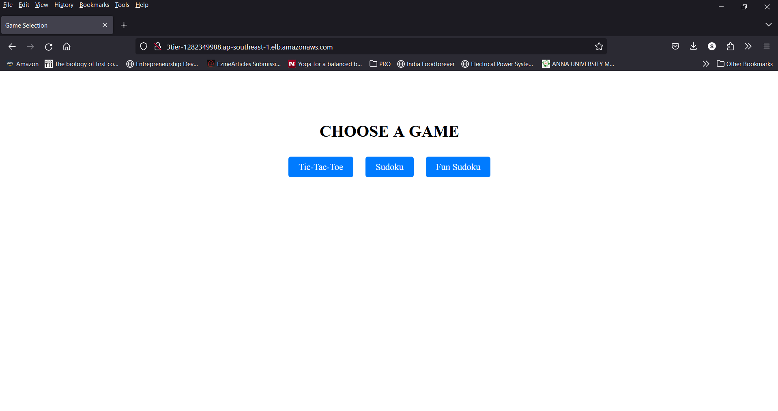

* Both servers lead to the same game files served from S3 bucket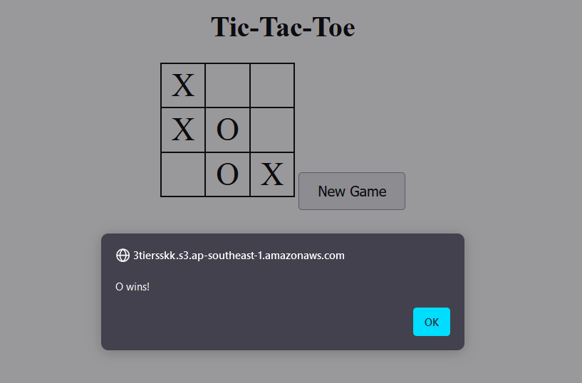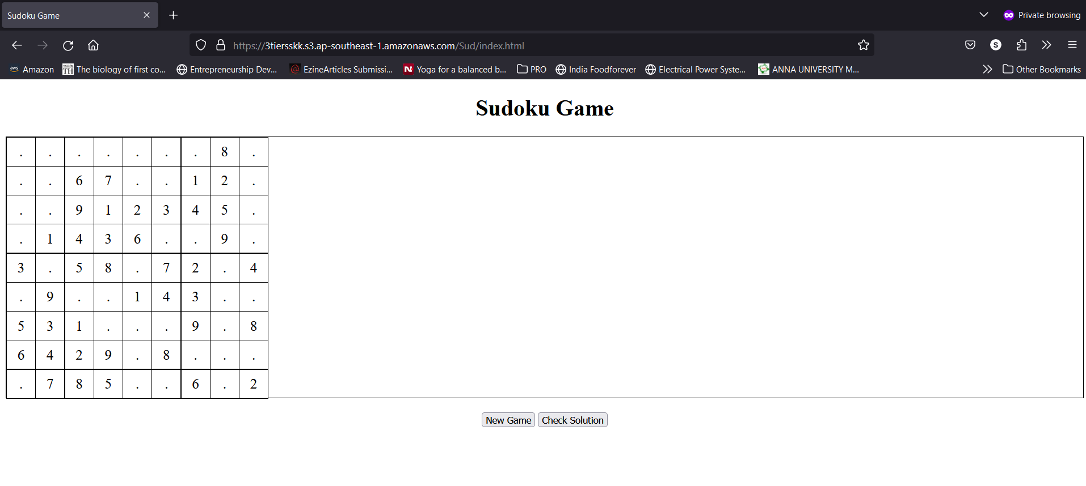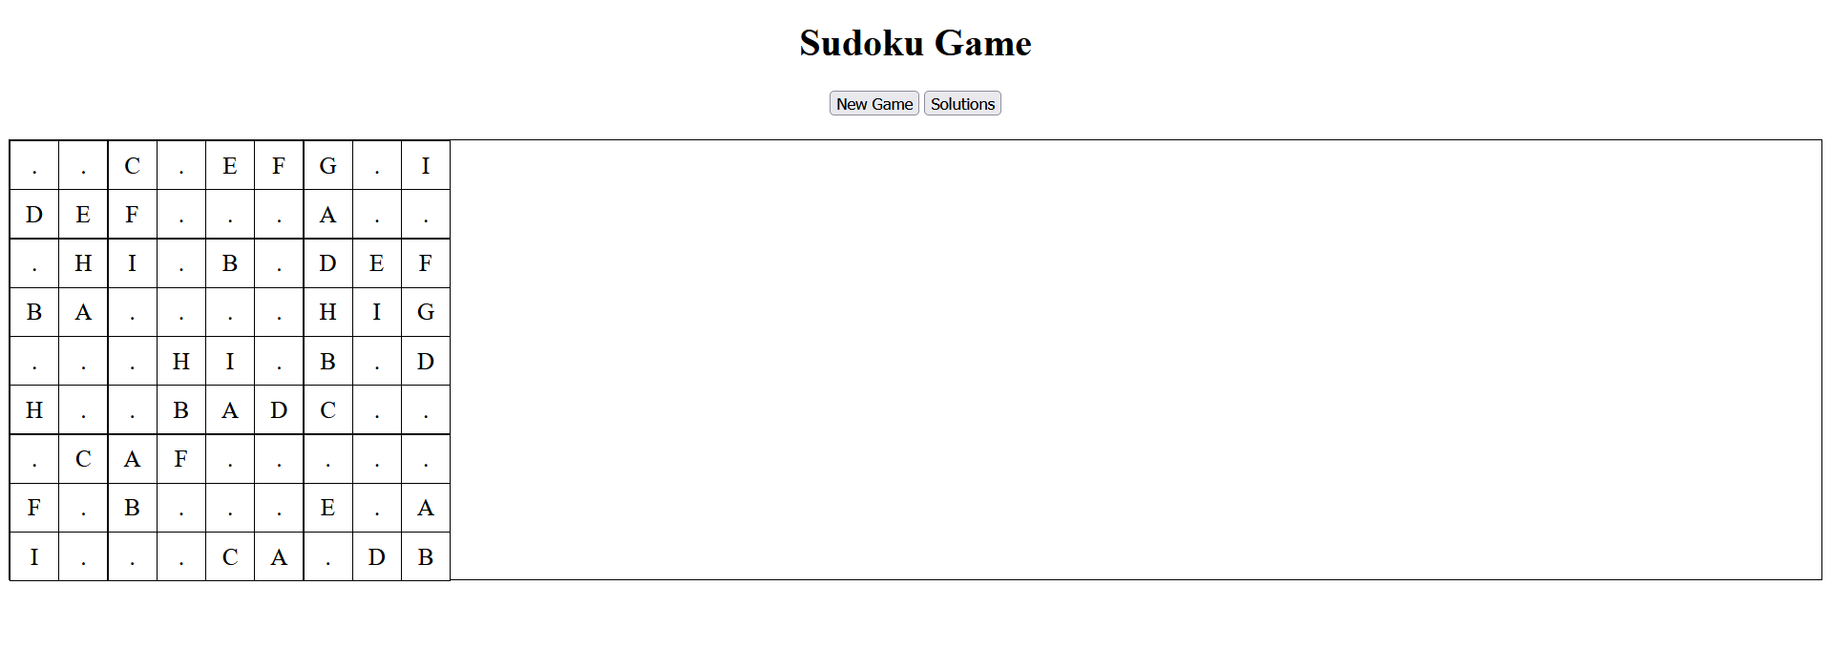

1. **Adding database to create third tier**
   1. **RDS Deployment**

* Choose the database engine that you want to use for your database instance. AWS RDS supports various engines such as MySQL, PostgreSQL, MariaDB, Oracle, and SQL Server. We are using the MySQL database.

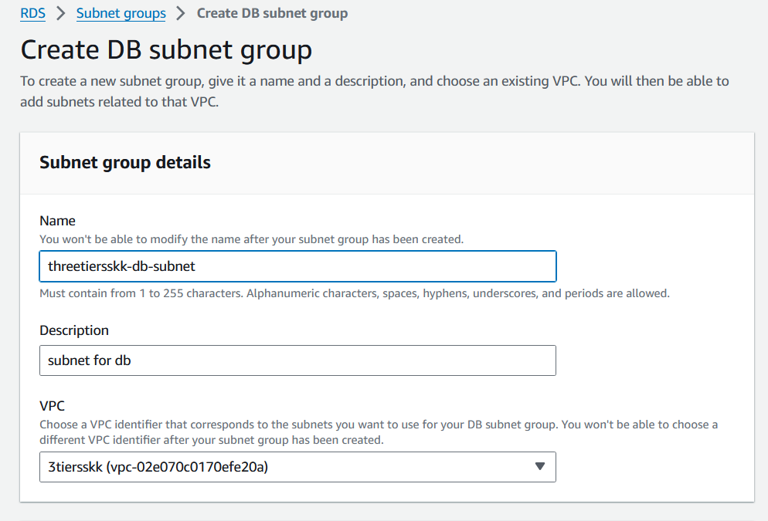

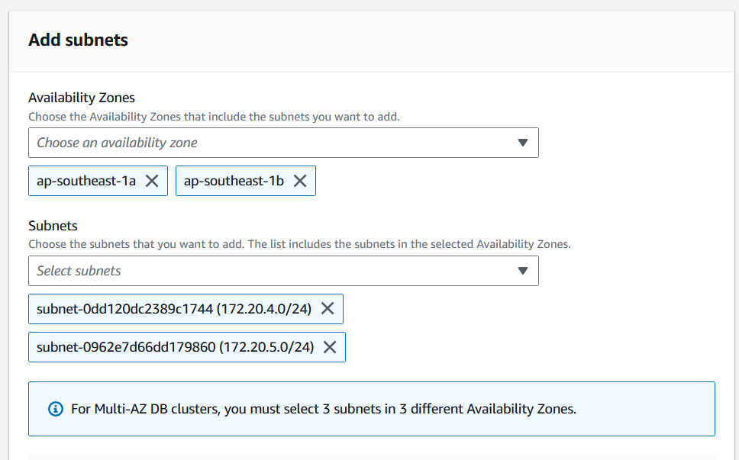

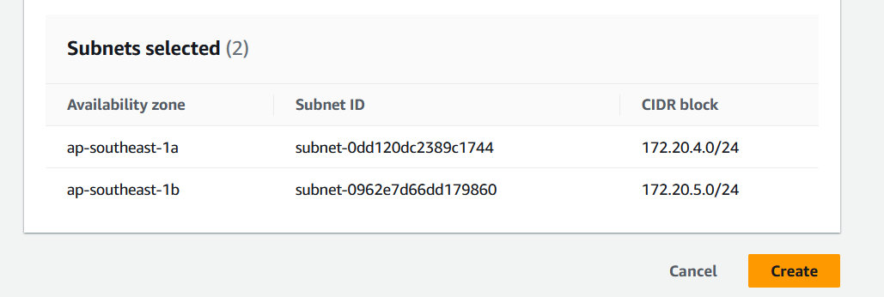

* Choose the "Standard Create" option and choose MySQL engine to create a new database instance

.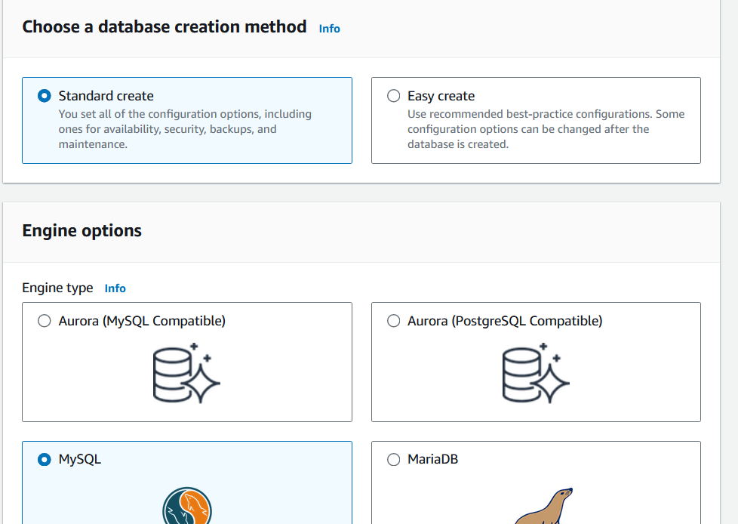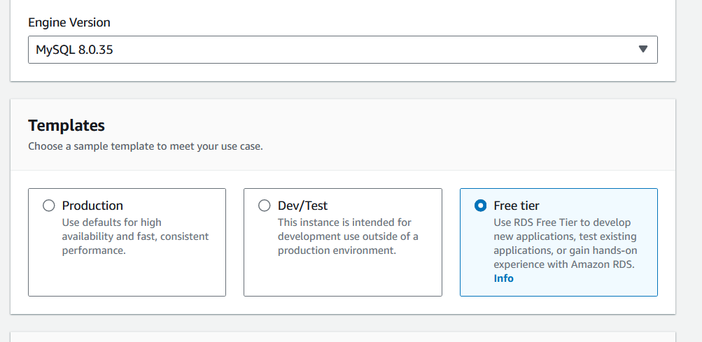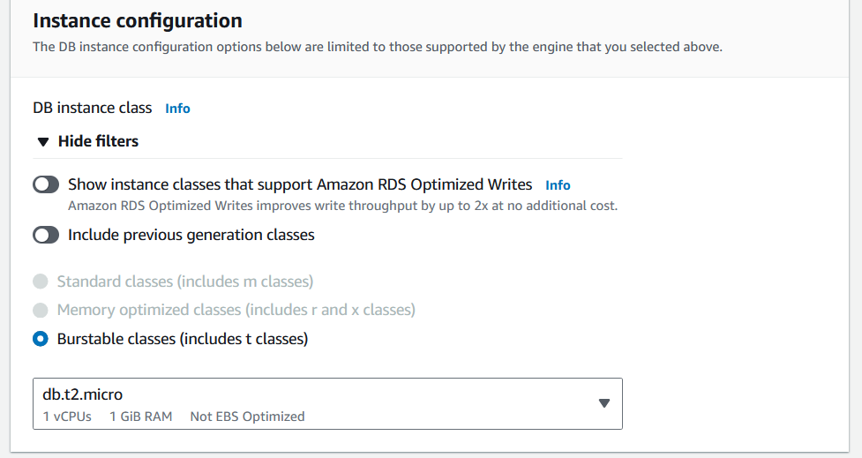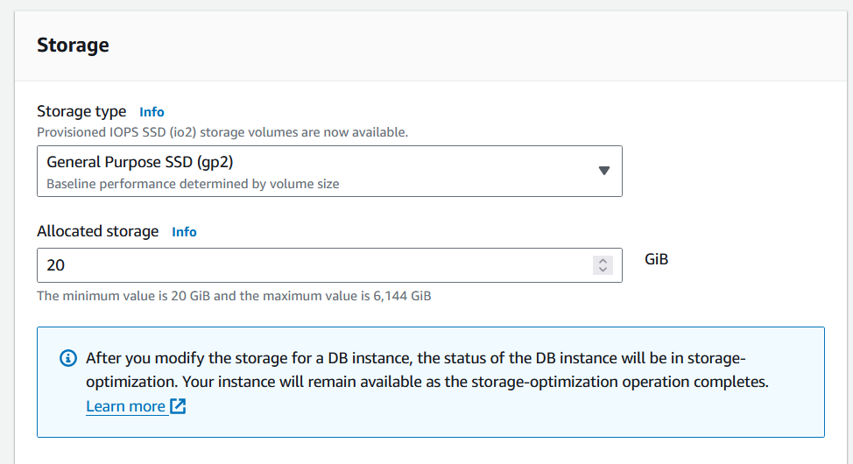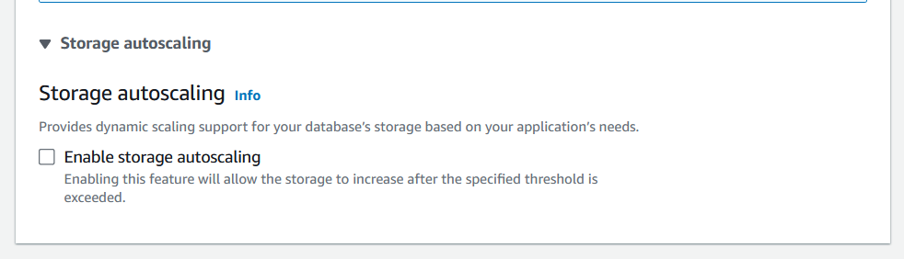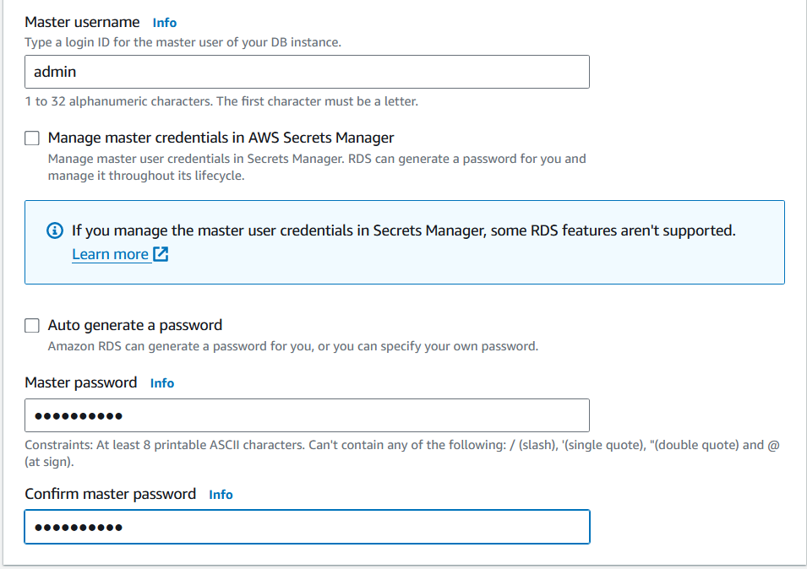

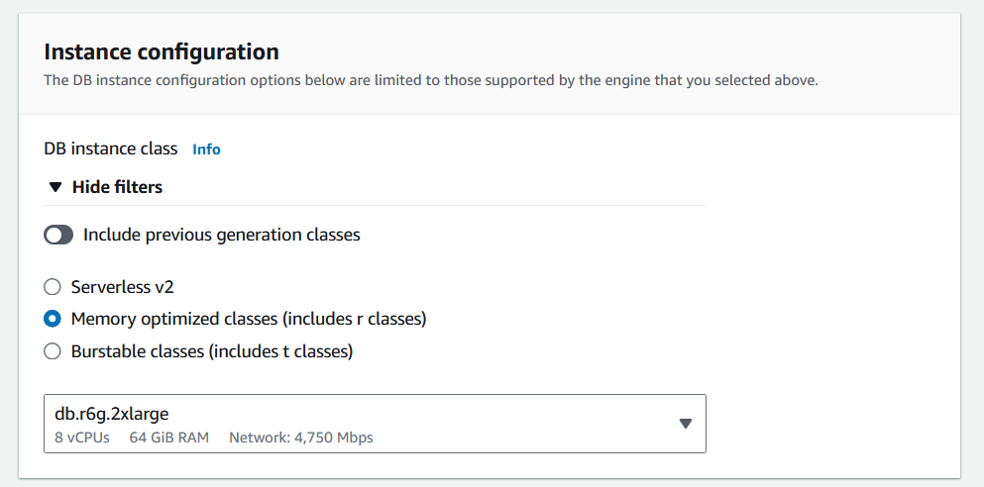

* Configure the VPC and subnet group to ensure the database is deployed within your desired network configuration.
* Specify the security group settings to control inbound and outbound traffic to the database instance. Allow inbound traffic from your application tier (e.g., EC2 instances) to access the database.

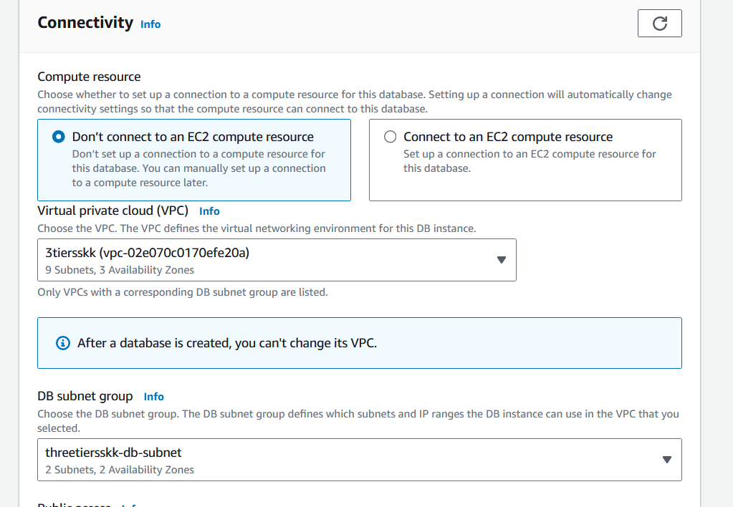

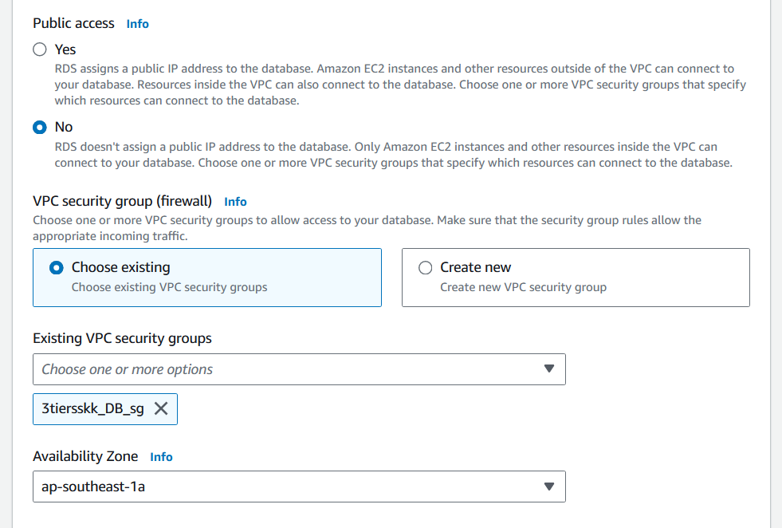

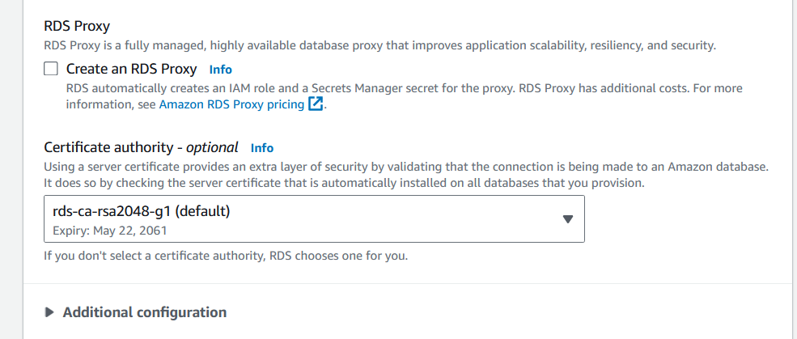

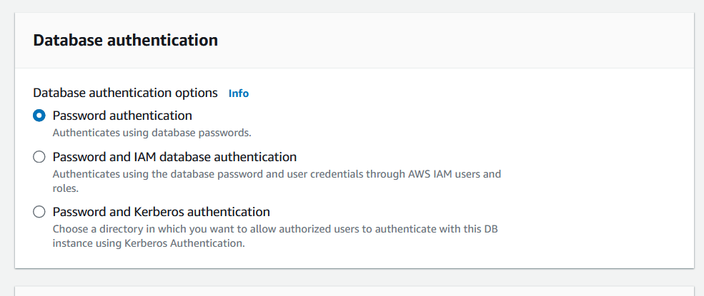

* Use the package management tool ( apt for Ubuntu) to install the MySQL server package.
* After MySQL server is installed, start the MySQL service
* MySQL installation comes with a default security script that you can run to secure your MySQL server installation

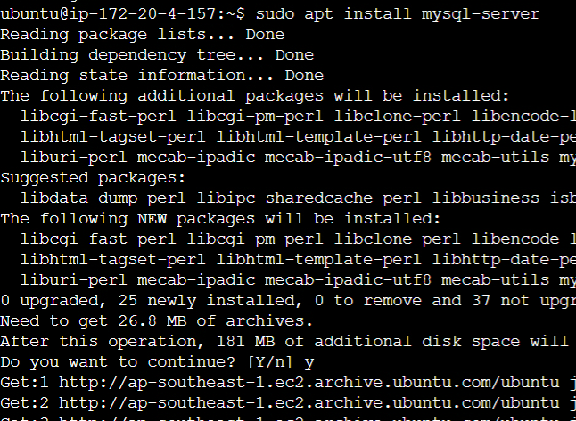

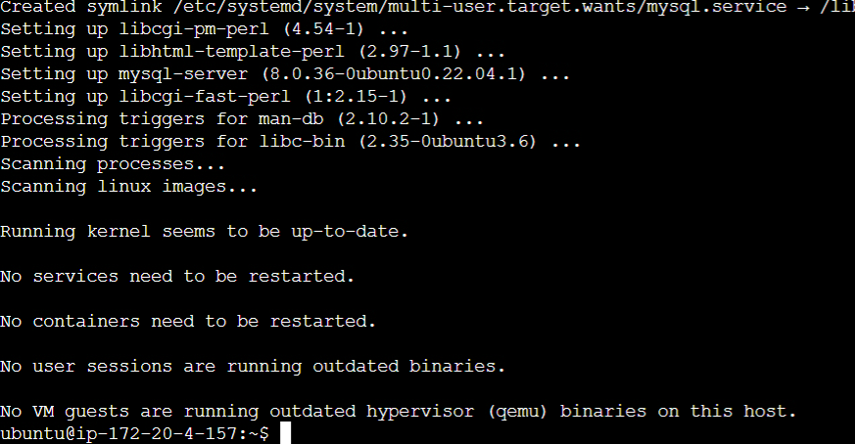 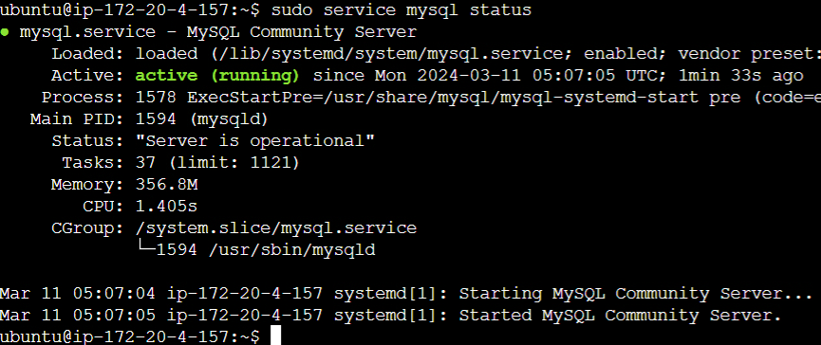



* If you haven't already created a database, you can create one
* After creating the database, switch to it

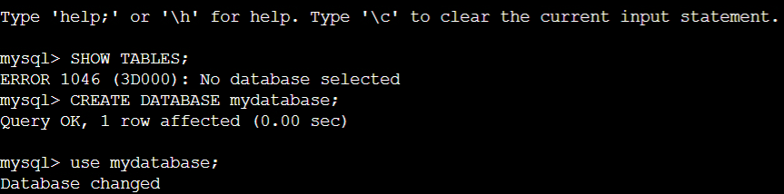

* Now, you can create tables within the database using the CREATE TABLE SQL command
* We are creating two tables. One with 5 columns and other with 3 columns.

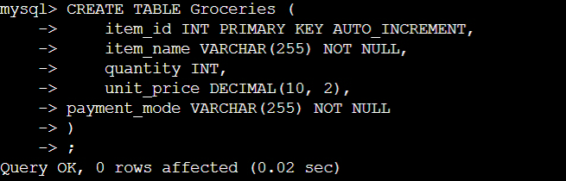

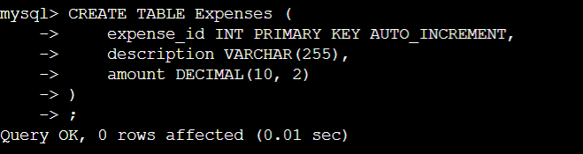

* After creating the table, you can view it by using the SHOW TABLES command

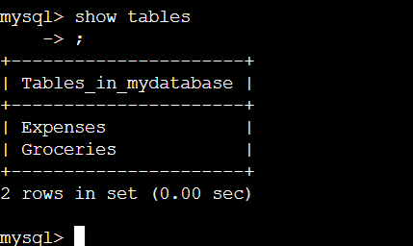

* To view the structure of a specific table, you can use the DESCRIBE command

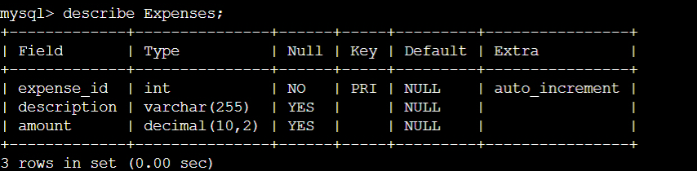

* Use the INSERT INTO SQL command to insert data into a specific table and verify the data using SELECT command.

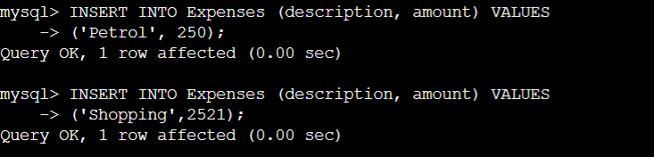

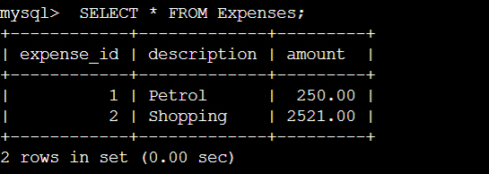



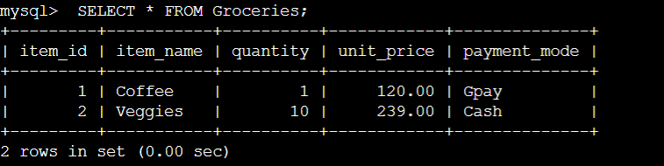

1. **Best practices and Points to remember**
   1. **Performance Standards:**

* **Response Time**: Aim for an average response time of less than 500 milliseconds for web requests.
* **Throughput**: Serve a minimum of 1000 requests per second during peak traffic.
* **Database Performance**: Ensure that critical database operations execute within predefined time limits.
  1. **Reliability Standards:**
* **Uptime**: Maintain a system uptime of at least 99.9% over a defined period.
* **MTBF (Mean Time Between Failures)**: Increase the MTBF to minimize system failures and downtime.
* **MTTR (Mean Time to Recover)**: Strive to reduce MTTR to quickly recover from incidents and minimize service disruption.
  1. **Scalability and Elasticity Standards:**
* **Auto Scaling Responsiveness**: Ensure that the Autoscaling Group responds promptly to changes in load, scaling instances as needed.
* **Elasticity Ratio**: Achieve an elasticity ratio that efficiently matches capacity to demand fluctuations.
  1. **Security and Compliance Standards:**
* **Zero Security Incidents**: Aim for zero security incidents or breaches by implementing robust security measures.
* **Compliance Adherence**: Ensure compliance with relevant regulations and internal security policies.
  1. **Cost Optimization Standards:**
* **Cost Efficiency**: Optimize infrastructure costs while maintaining performance and reliability, achieving a predefined cost reduction target.
* **Resource Utilization**: Ensure efficient resource utilization to avoid over-provisioning and unnecessary expenses.
  1. **User Experience Standards:**
* **High User Satisfaction**: Maintain high user satisfaction scores through regular feedback and improvements.
* **Low Error Rates**: Strive for a low error rate in the application to enhance user experience and reliability.
* **Improvement in Conversion Rates**: Measure and improve conversion rates to demonstrate positive user engagement.
  1. **Monitoring and Incident Response Standards:**
* **Prompt Alert Response**: Acknowledge and respond to alerts promptly, ensuring swift incident resolution.
* **Efficient Incident Resolution**: Resolve incidents quickly to minimize service disruption and impact on users.
* **Minimize False Positives**: Reduce false positive alerts to improve incident response efficiency.
  1. **Continuous Improvement Standards:**
* **Iterative Development**: Embrace iterative development practices to continuously deliver new features and enhancements.
* **Feedback Loop Integration**: Establish a feedback loop to gather user and stakeholder feedback for continuous improvement.
* **Technical Debt Reduction**: Continuously address and reduce technical debt to maintain system agility and sustainability.

1. **Additional elements and features followed as per current trend**

To enhance the quality and value of the project, we can incorporate additional elements or features that improve various aspects such as performance, scalability, security, user experience, and maintainability. Here are some suggestions:

* 1. **Performance Optimization:**
* Implement caching mechanisms (e.g., Redis, Memcached) to reduce latency and improve response times.
* Use Content Delivery Networks (CDNs) to deliver static content closer to users and reduce load on origin servers.
* Optimize database queries and indexes to improve database performance.
  1. **Scalability Enhancements:**
* Implement asynchronous processing using message queues (e.g., Amazon SQS, RabbitMQ) to decouple components and handle spikes in traffic.
* Explore serverless computing (e.g., AWS Lambda, Azure Functions) for handling intermittent or bursty workloads.
* Horizontal scaling of components using containerization (e.g., Docker) and orchestration tools (e.g., Kubernetes) for better resource utilization.
  1. **Security Features:**
* Implement multi-factor authentication (MFA) for user accounts to enhance security.
* Integrate intrusion detection and prevention systems (IDS/IPS) to monitor and protect against security threats.
* Conduct regular security audits and penetration testing to identify and mitigate vulnerabilities.
  1. **User Experience Enhancements:**
* Implement responsive web design to ensure optimal viewing experience across different devices and screen sizes.
* Enhance accessibility features to make the application usable by a wider range of users, including those with disabilities.
* Implement personalization features based on user preferences and behavior to improve engagement.
  1. **Monitoring and Analytics:**
* Implement comprehensive monitoring and logging solutions (e.g., ELK stack, Splunk) to track application performance and diagnose issues.
* Use A/B testing and user analytics tools to gather insights into user behavior and preferences for data-driven decision making.
* Implement anomaly detection algorithms to automatically detect and alert on unusual behavior or performance degradation.
  1. **Documentation and Knowledge Sharing:**
* Create thorough documentation covering architecture, deployment procedures, troubleshooting guides, and best practices.
* Establish a knowledge sharing platform or internal wiki to facilitate collaboration and knowledge transfer among team members.
* Conduct regular code reviews and provide feedback to improve code quality and maintainability.
  1. **Integration with Third-party Services:**
* Integrate with external services (e.g., payment gateways, social media platforms) to extend functionality and provide additional value to users.
* Implement APIs for third-party developers to extend the platform and encourage ecosystem growth.
* Explore partnerships with complementary services or platforms to enhance the overall offering.
  1. **Continuous Improvement Processes:**
* Implement continuous integration and continuous deployment (CI/CD) pipelines to automate software delivery and deployment processes.
* Establish regular retrospective meetings to reflect on past iterations and identify areas for improvement.
* Foster a culture of innovation and experimentation, encouraging team members to propose and explore new ideas and technologies.

Incorporating these additional elements or features can significantly enhance the quality, value, and overall success of the project while providing learners with valuable experience in building robust and scalable software systems.